**PowerShell**:

PowerShell is built on top of the .NET Common Language Runtime (CLR) and accepts and returns .NET objects. PowerShell is a cross-platform task automation and configuration management framework. The commands in PowerShell are known as **cmdlets.** Cmdlet is pronounced **command-let**.

PowerShell Command to Find the Version: $PSVersionTable.PSVersion.

PowerShell providers enable you to access other data stores, such as the registry and the certificate stores, as easily as you access the file system.

To get help for a PowerShell cmdlet, type `Get-Help` followed by the cmdlet name, such as: `Get-Help Get-Process`.

Power Shell Gallery : <https://www.powershellgallery.com/>

Powershell should be learn as administration else you may encounter the error as.

error: Cannot open W32Time service on computer '.'.

**Software Installation**: A newer version of the .NET Framework which is required by the newer version of PowerShell to be installed on the servers that their software is installed on.

**Execution Policy:**

Be Sure that execution policy return remoteSigned which should be run in administration mode.

Display output page : Get-ChildItem | Out-Host -Paging

**Get-Member** cmdlet displays information about the object returned by **Get-Location**.

**The Three Core Cmdlets in PowerShell**

• Get-Command • Get-Help • Get-Member

--Get-Help about_*

-- Get-Help about_Comparison_Operators

-- Get-Help Get-Process -Online

PowerShellGet requires NuGet provider version '2.8.5.201' or newer to interact with NuGet-based repositories. The NuGet provider must be available in 'C:\Program Files\PackageManagement\ProviderAssemblies'. – Page 76

**Find-Module -Name MrToolkit | Install-Module**

To see the examples,

type: "get-help Get-Help -examples".

For more information, type: "get-help Get-Help -detailed".

For technical information, type: "get-help Get-Help -full".

For online help, type: "get-help Get-Help -online"

Recommended- help Get-Command -Full | Out-GridView

REMARKS To see the examples,

type: "get-help Get-HotFix -examples".

For more information, type: "get-help Get-HotFix -detailed".

For technical information, type: "get-help Get-HotFix -full".

For online help, type: "get-help Get-HotFix -online"

Example: Get-Location | Get-Member

1. Get-Service -Name W32Time | Stop-Service
2. $PSVersionTable
3. $PSVersionTable.PSVersion
4. Get-ExecutionPolicy
5. Set-ExecutionPolicy -ExecutionPolicy RemoteSigned
6. Get-ExecutionPolicy
7. Get-update
8. Get-Help.
9. Or - Update-Help -UICulture en-US.
10. help *process*
11. dir env:
12. get-service | export-csv C:\Users\31311\Desktop\services.csv
13. get-service | export-clixml C:\Users\31311\Desktop\services.xml
14. notepad .\servcies.csv
15. Compare-Object -ReferenceObject(import-clixml C:\Users\31311\Desktop\Mine\RRK_ANGU\baseline.xml) -DifferenceObject (get-process) -Property Name
16. get-service | convertto-html | out-file C:\Users\31311\Desktop\Mine\RRK_ANGU\baseline.html
17. Get-Command -Name *service*
18. Get-Command -Name *service* -CommandType Cmdlet, Function, Alias
19. Get-Service -Name w32time | Get-Member
20. Get-Command -ParameterType ServiceController
21. Get-Service -Name w32time | Select-Object -Property *
22. Get-Service -Name w32time | Get-Member -MemberType Method
23. (Get-Service -Name w32time).Stop()
24. Get-Service -Name w32time | Start-Service -PassThru
25. Get-Process -Name PowerShell | Get-Member
26. Get-Command -Module ActiveDirectory
27. Get-ADUser -Identity mike | Get-Member
28. Get-ADUser -Identity mike -Properties * | Get-Member
29. $Users = Get-ADUser -Identity mike -Properties *
30. $Users | Get-Member
31. $Users | Select-Object -Property Name, LastLogonDate, LastBadPasswordAttempt
32. Get-ADUser -Identity mike -Properties LastLogonDate, LastBadPasswordAttempt
33. help about_profile
34. import-module activedirectory
35. get-module -ListAvailable
36. get-eventlog -LogName security -Newest 50
37. get-service | sort status
38. import-csv users.csv | Select Name,Department,City,@{n='title';e={$_.'Job Title'},@{n='samaaccountname';e={$_.name}} | new_aduser
39. Get-Service | Where-Object {$_.CanPauseAndContinue -eq "true"} | Select-Object -property *
40. $CustomObject = [pscustomobject]@{

Name = 'w32time'

}

$CustomObject | Get-Member

1. $CustomObject | 2 >> Select-Object -Property @{label='Name';Expression={$_.Service}} |

Stop-Service – Note : Mapping input and output of command.

1. 'Background Intelligent Transfer Service', 'Windows Time' | Out-file -FilePath

$env:TEMP\services.txt | notepad $env:TEMP\services.txt

1. Stop-Service -DisplayName (Get-Content -Path $env:TEMP\services.txt)
2. Enter-PSSession -ComputerName server-r2
3. invoke-command -scriptblock { get-service } -computer localhost
4. Exit-PSSession
5. Help Remote_about
6. GWMI Win32_BIOS -computer server-r2 -credential Administrator
7. Get-Job
8. Get-Alias -Definition "*-PSSession" -Exclude e* -Scope local
9. Get-alias GCM
10. Import-Module -Name ActiveDirectory, SQLServer
11. Get-PSprovider
12. Get-ChildItem -Path Cert:\LocalMachine\CA
13. PowerShell' -like '*shell'
14. $Numbers = 1..10
15. $Numbers -contains 15
16. 'ActiveDirectory', 'SQLServer' | ForEach-Object {Get-Command -Module $_} | Group-Object -Property ModuleName -NoElement |Sort-Object -Property Count -Descending
17. 'DC01', 'WEB01' | Get-ADComputer
18. $guess = Read-Host -Prompt "What's your guess?"
19. Write-Output 'Too high!'
20. **Get-Command -Module CimCmdlets**
21. Get-Command -Noun WMI*
22. Get-CimInstance -ClassName Win32_BIOS
23. Get-CimInstance -ClassName Win32_BIOS | Select-Object -Property SerialNumber
24. Get-CimInstance -Namespace root -ClassName __Namespace
25. Get-CimInstance -Query "SELECT * from Win32_Process WHERE name LIKE 'P%'"
26. Get-CimInstance -ClassName Win32_ComputerSystem -ComputerName Server01,Server02
27. $CimSession = New-CimSession -ComputerName dc01 -Credential (Get-Credential)
28. Get-CimInstance -CimSession $CimSession -ClassName Win32_BIOS
29. Test-WSMan -ComputerName dc01
30. $DCOM = New-CimSessionOption -Protocol Dcom
31. $Cred = Get-Credential
32. $CimSession = New-CimSession -ComputerName sql03 -SessionOption $DCOM -Credential $ Cred
33. Get-CimInstance -CimSession $CimSession -ClassName Win32_BIOS
34. $CimSession = Get-CimSession
35. Get-CimSession | Remove-CimSession
36. Get-Command -ParameterName ComputerName
37. PowerShell version 2.0 or higher must exist on the remote computer and PowerShell remoting must be enabled on the remote computer
38. Enable-PSRemoting
39. Enter-PSSession -ComputerName dc01 -Credential $Cred
40. Exit-PSSession
41. Invoke-Command -ComputerName dc01, sql02, web01 {Get-Service -Name W32time} -Credential $Cred
42. Invoke-Command -ComputerName dc01, sql02, web01 {(Get-Service -Name W32time).stop( )} -Credential $Cred
43. Invoke-Command -ComputerName dc01, sql02, web01 {Get-Service -Name W32time}

-Credential $Cred

86. $Session = New-PSSession -ComputerName dc01, sql02, web01 -Credential $Cred

87. Invoke-Command -Session $Session {(Get-Service -Name W32time).start()}

88. Invoke-Command -Session $Session {Get-Service -Name W32time}

89. Get-PSSession | Remove-PSSession

90.

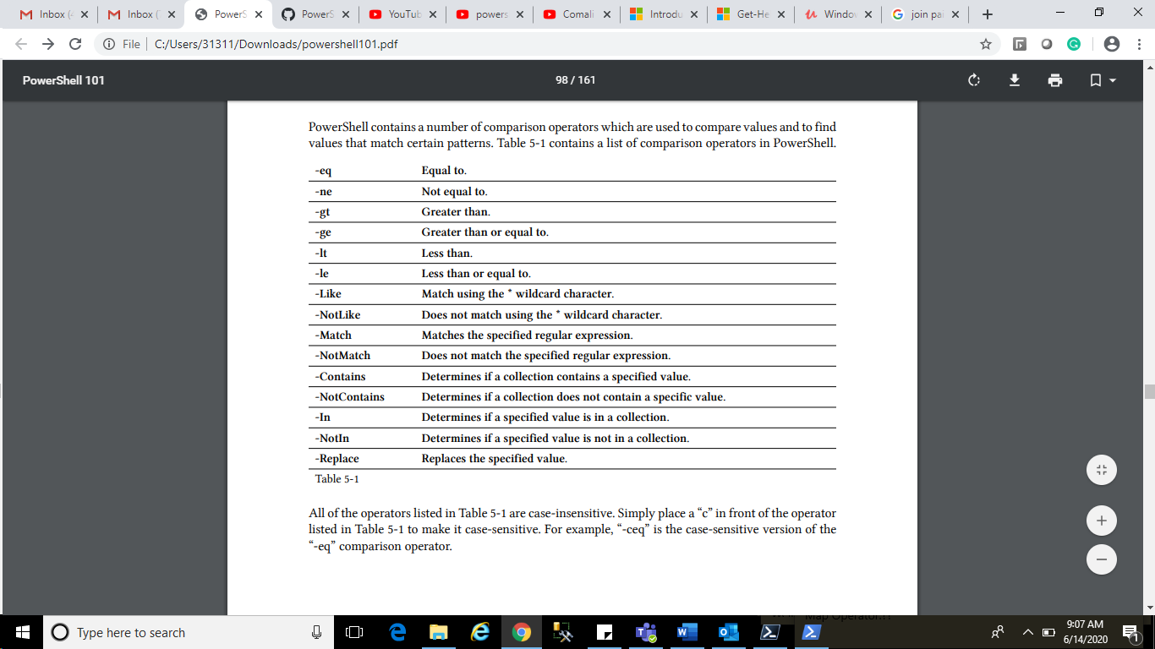

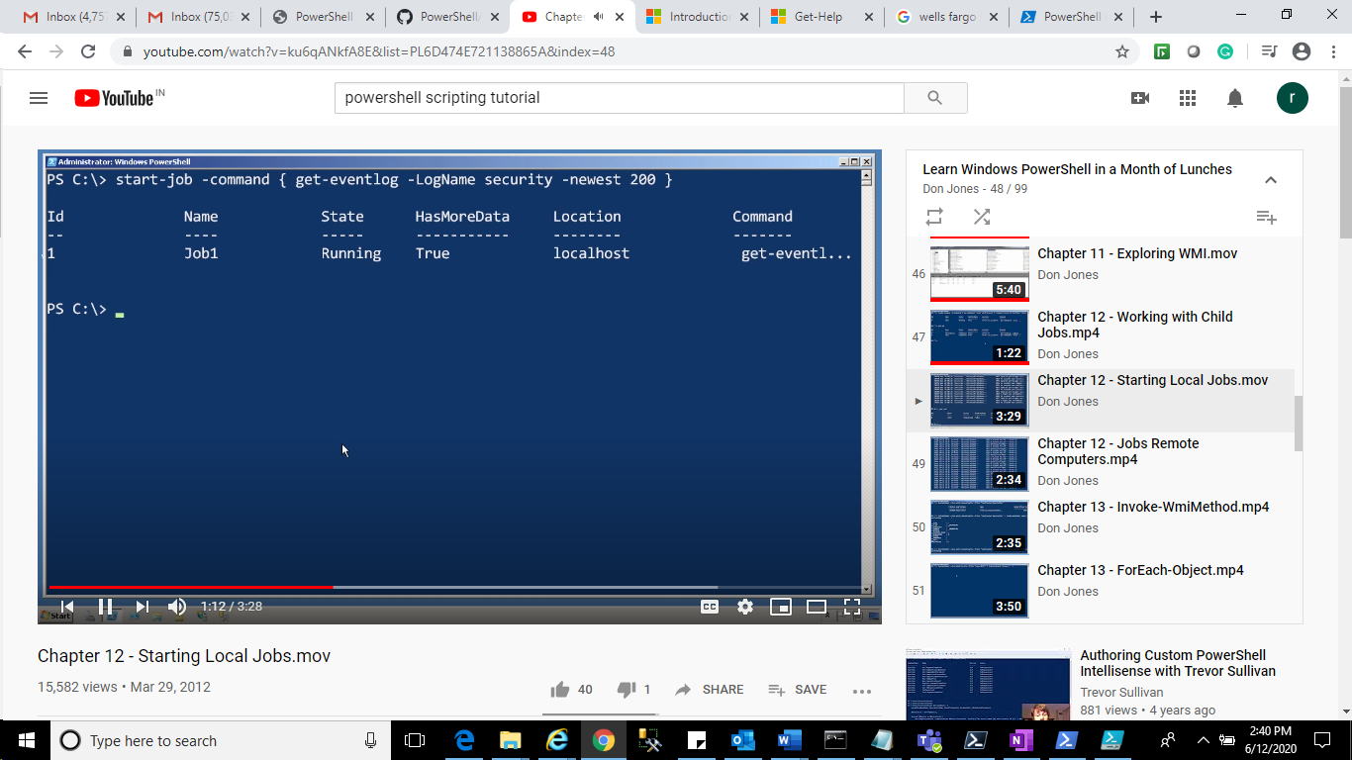

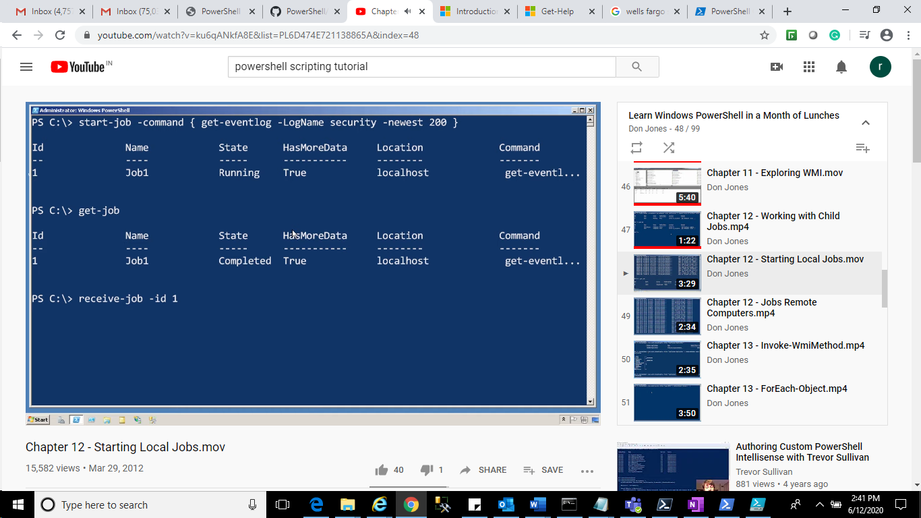

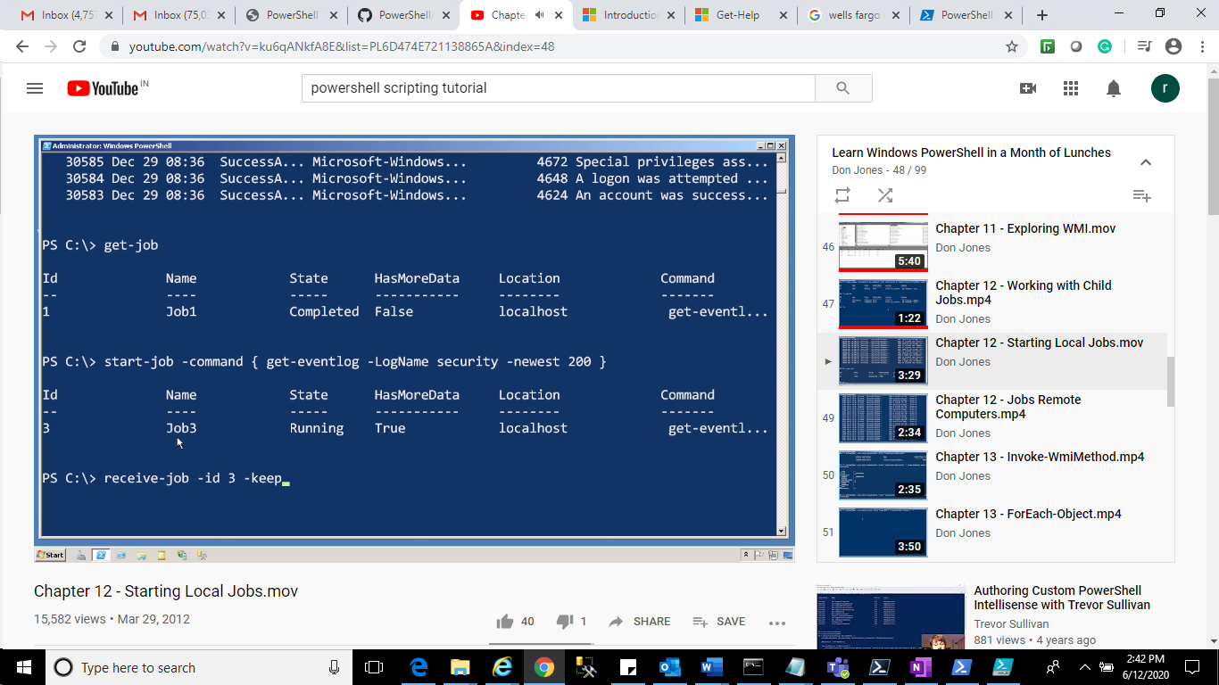

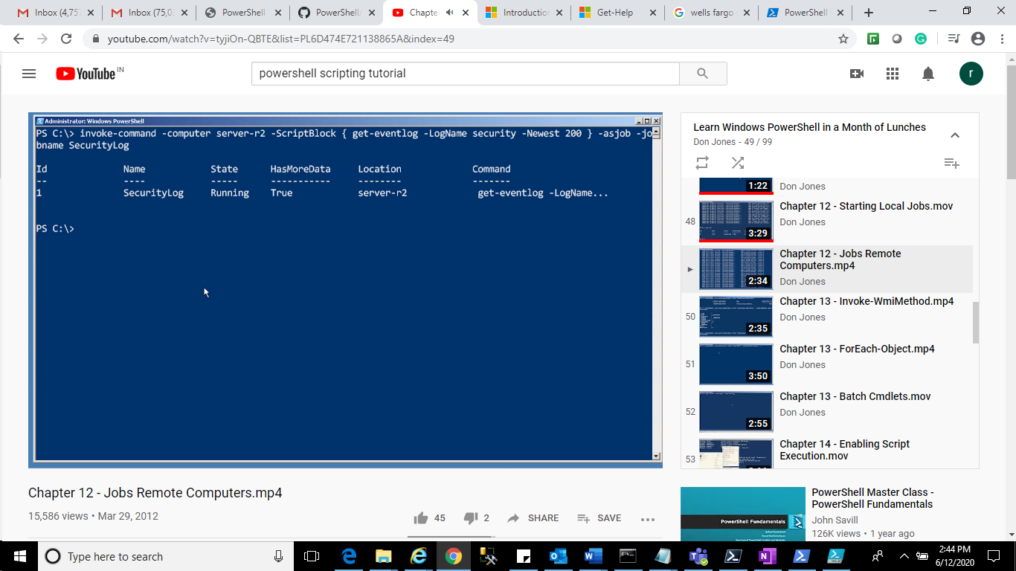

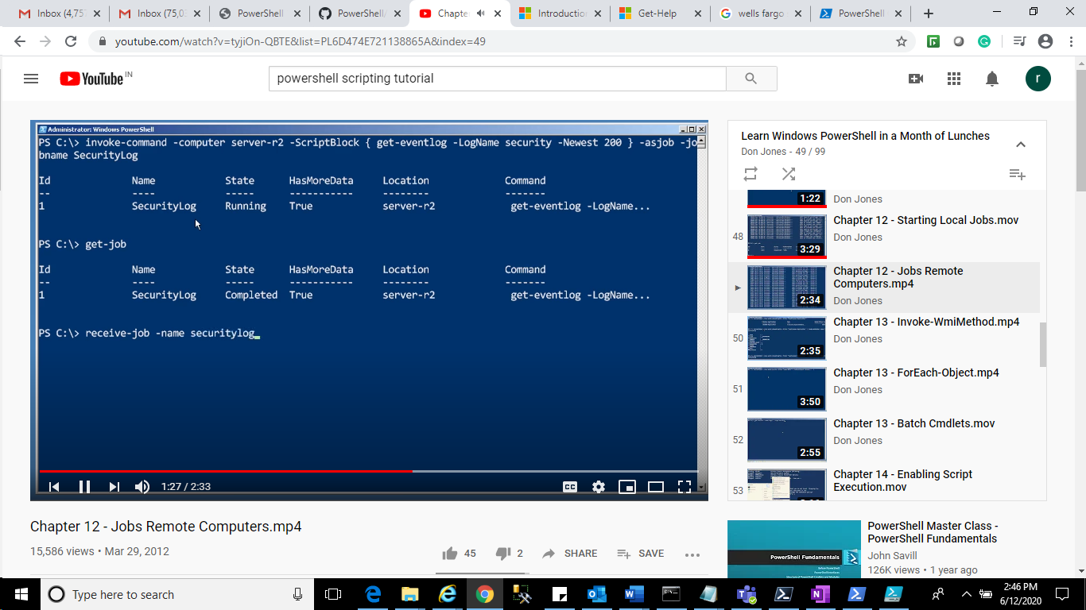

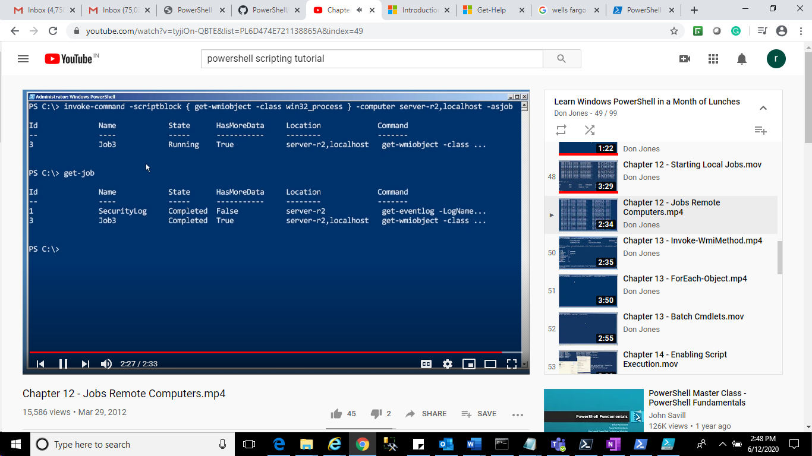

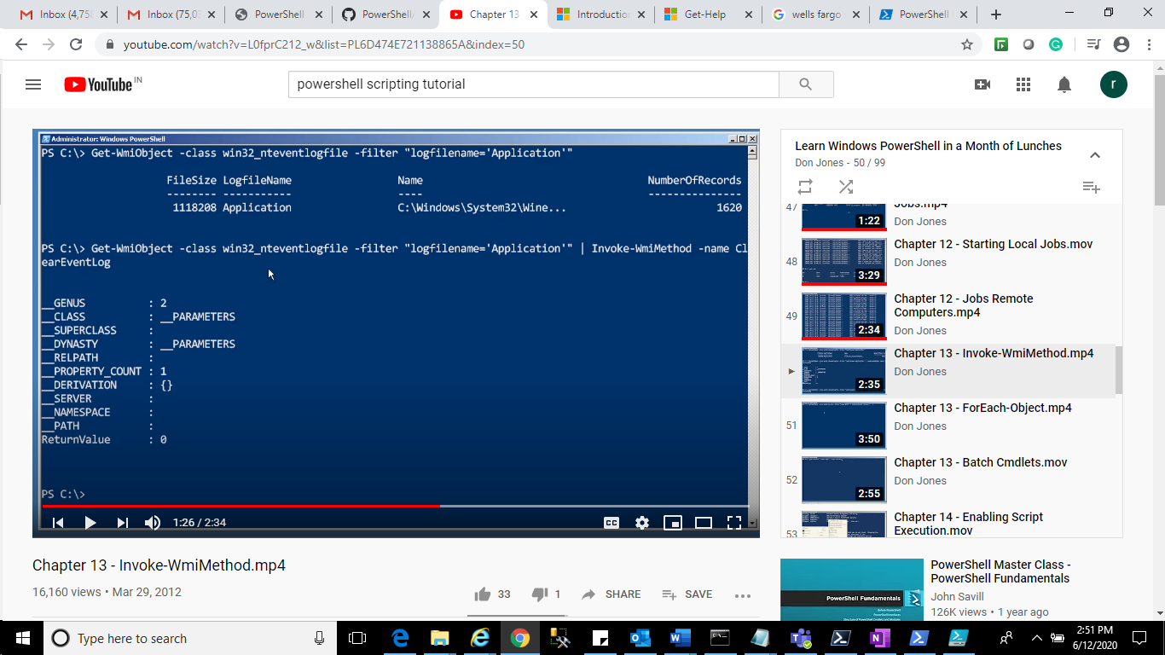

Clear Event Log –

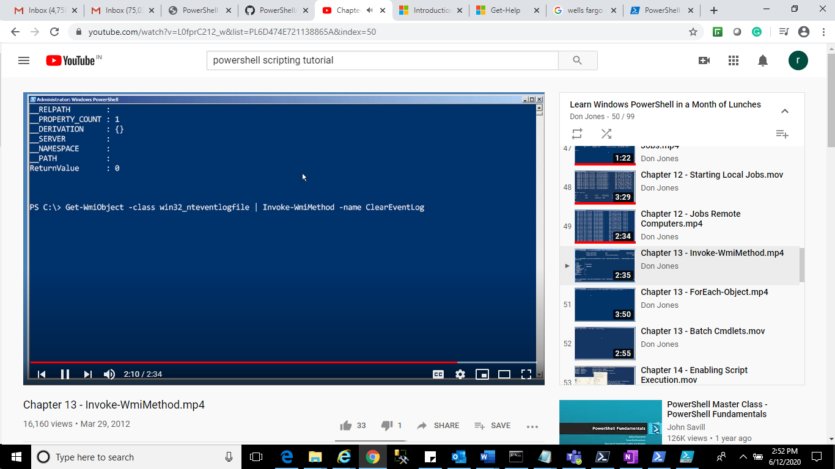

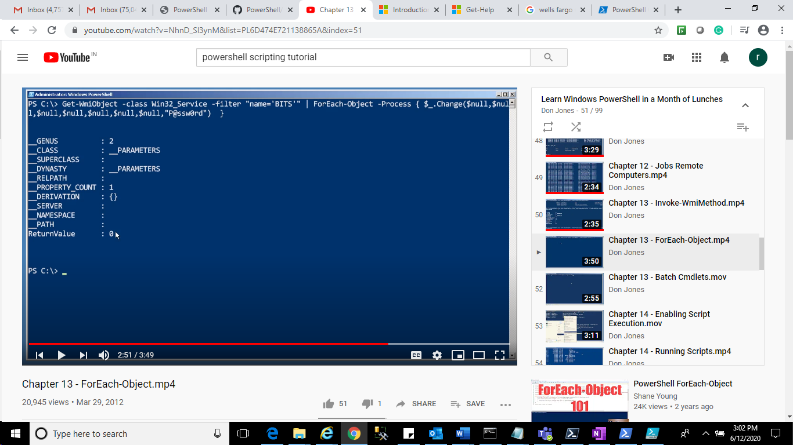

Batch Cmdlts:

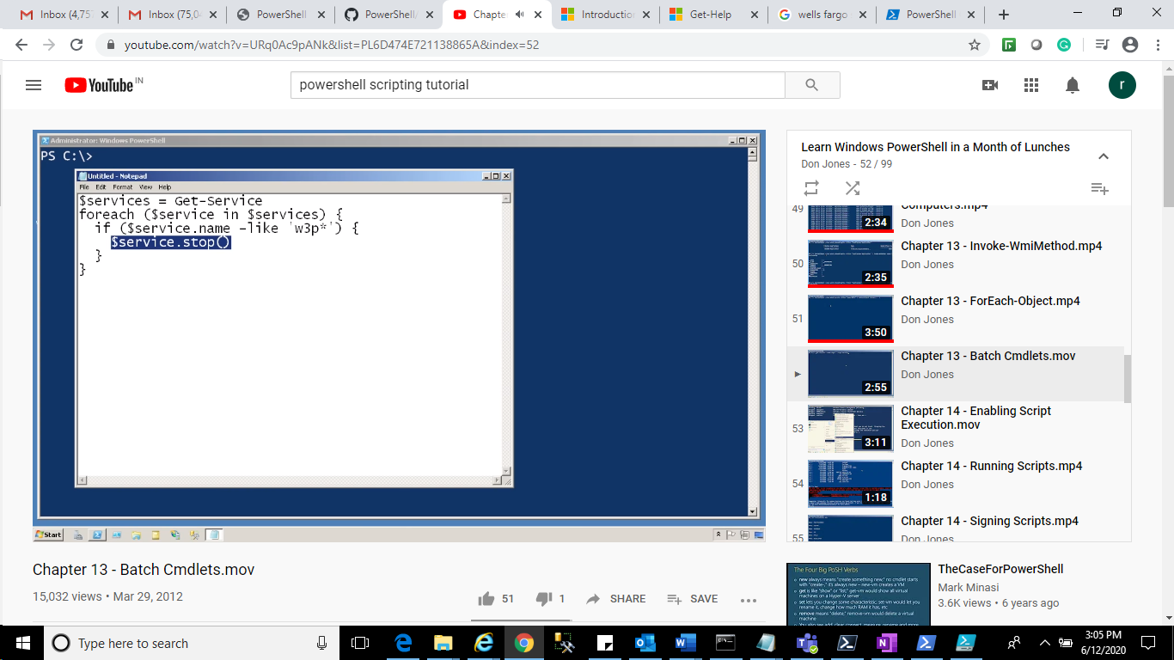

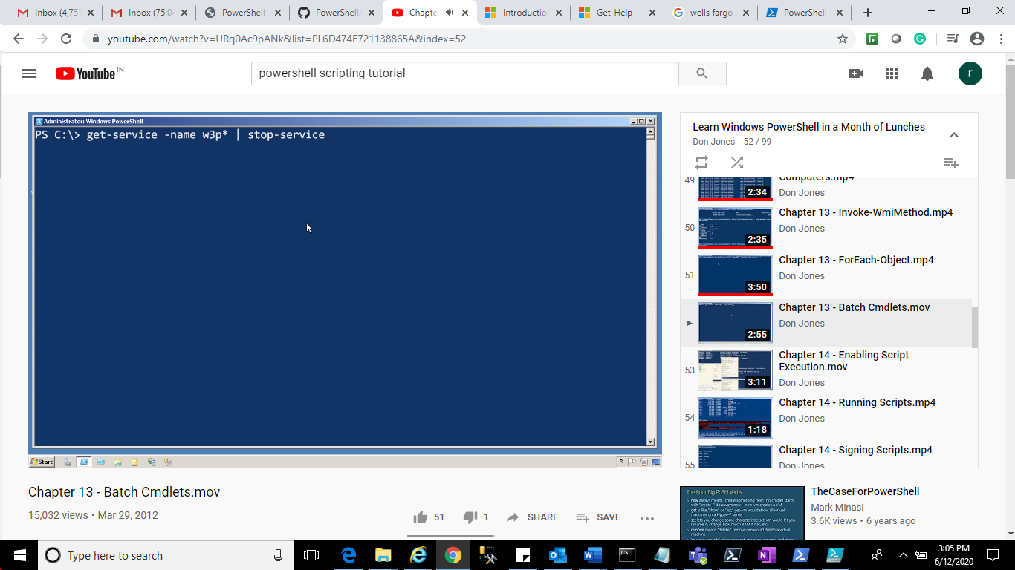

Enable Script Execution

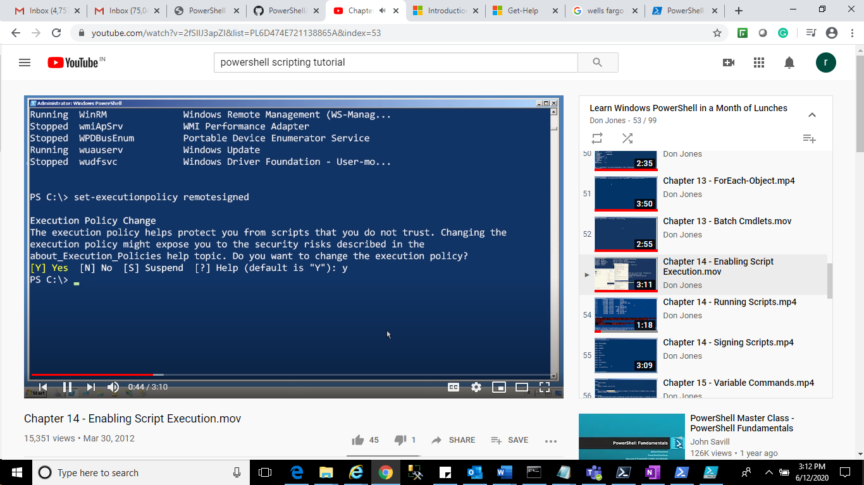

Group policy inside, we have to made changes also.

**Running Script:**

"write-host 'host'" | out-file test.ps1

./test(path should be specified)

**Signing Script:**

Internet Option -> content -->publisher -->

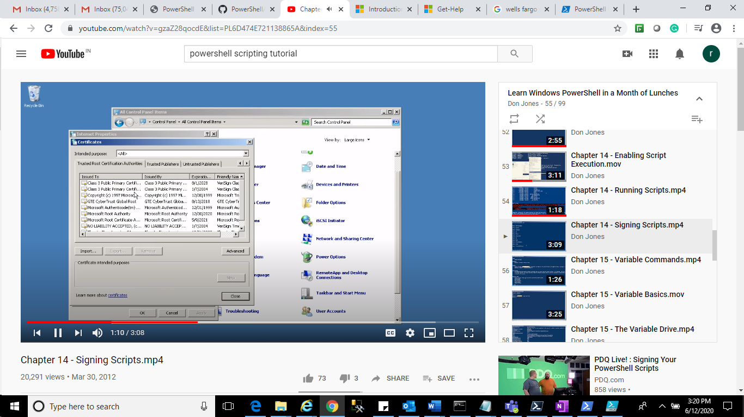

Once you have certificate, you may install the certificate.

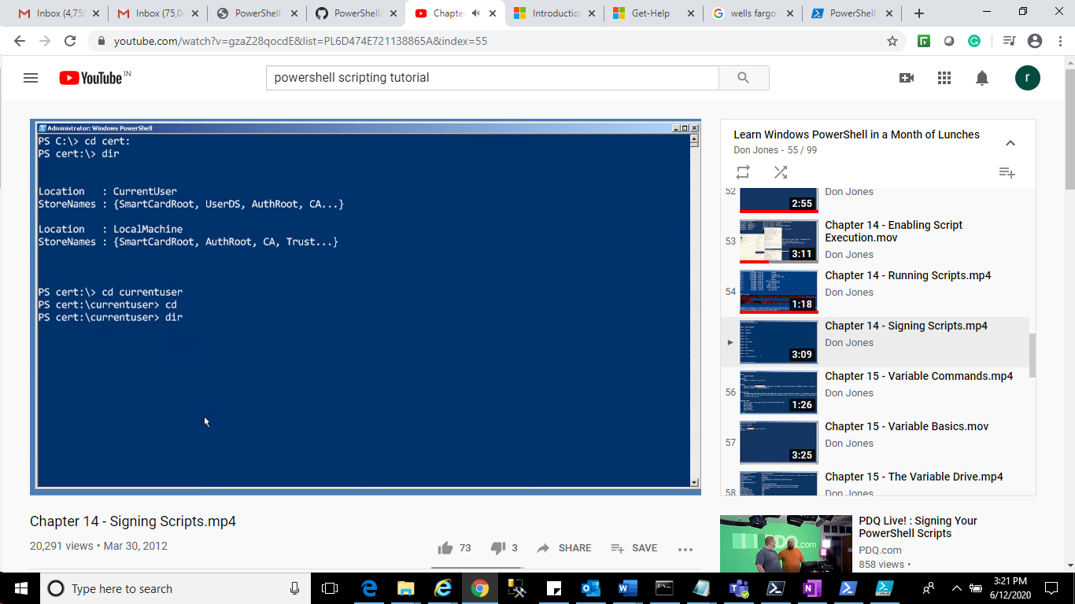

**Variable Command:**

Get-command -noun variable

Remove-Variable -name a

dir variable:

Read Host:

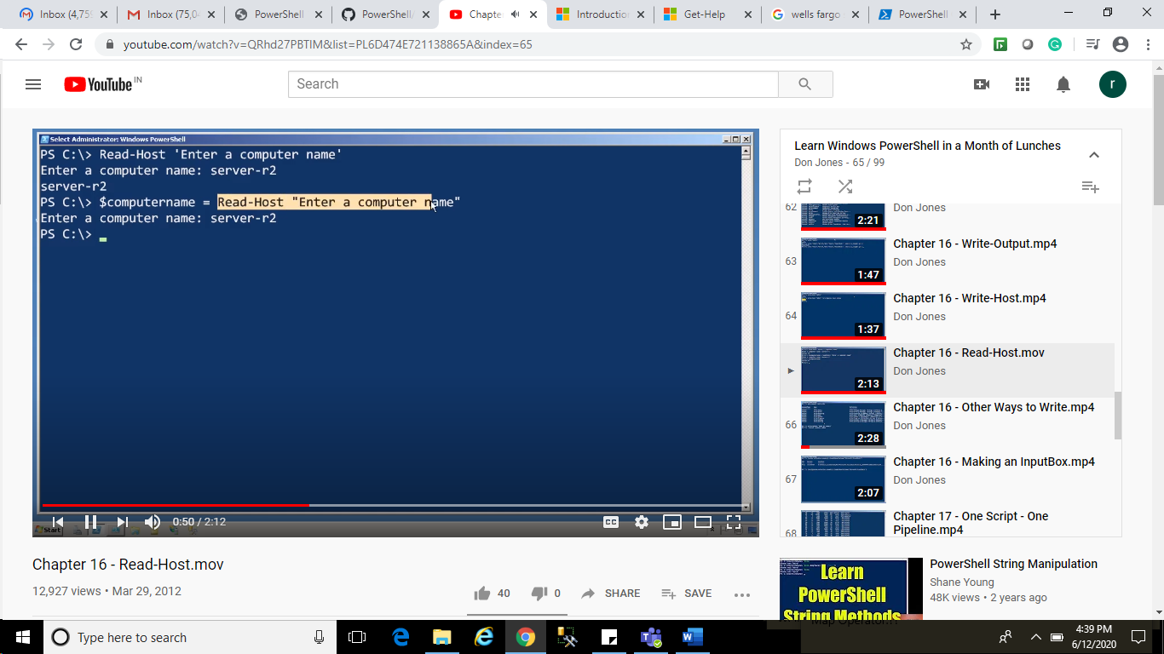

Write in other way:

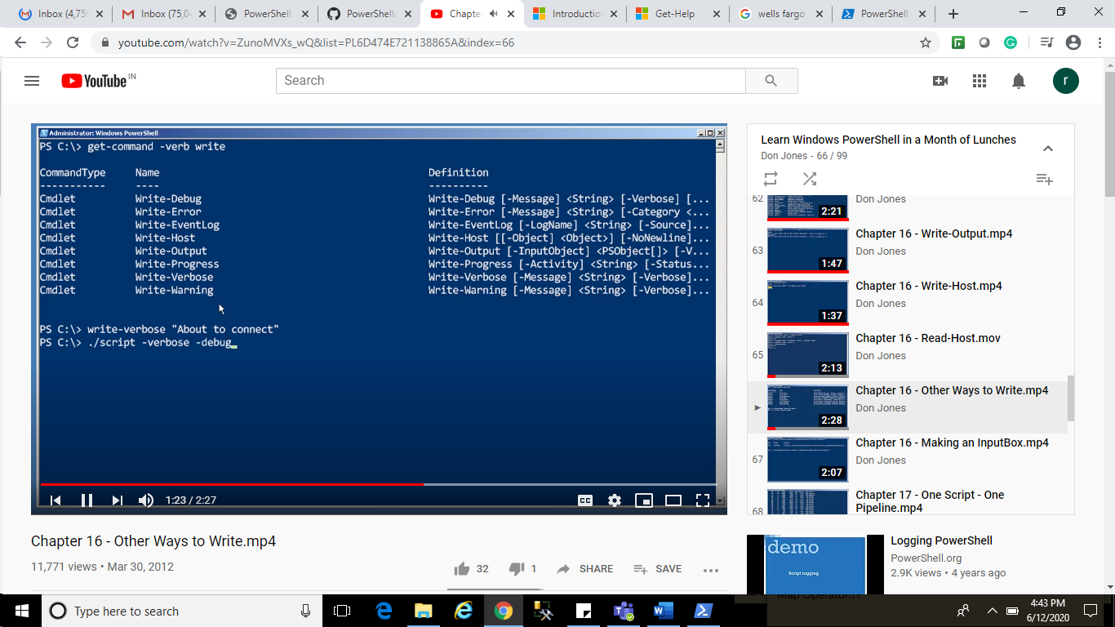

Creating Input Box:

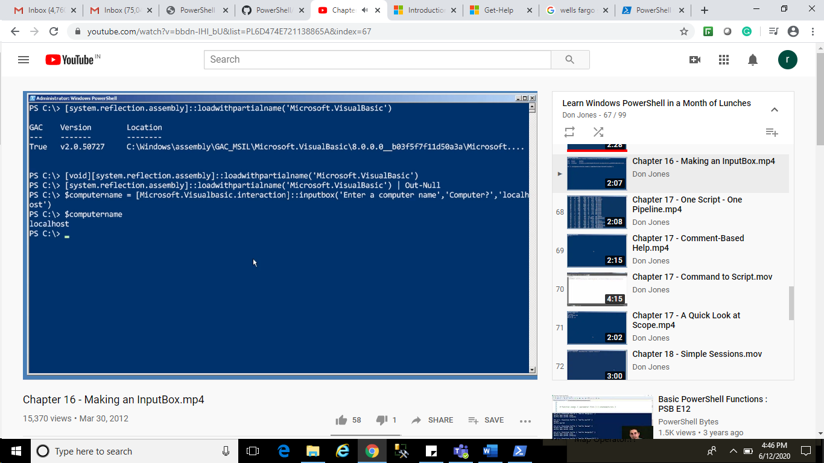

One Script – one pipe Line:

Command Based Help:

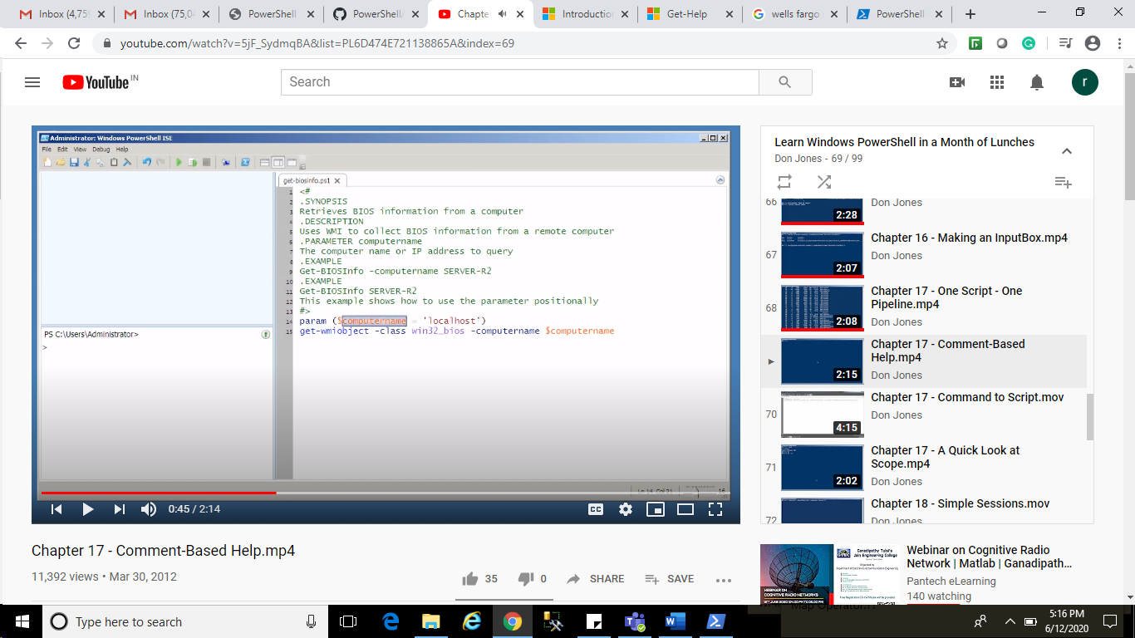

Command to Script:

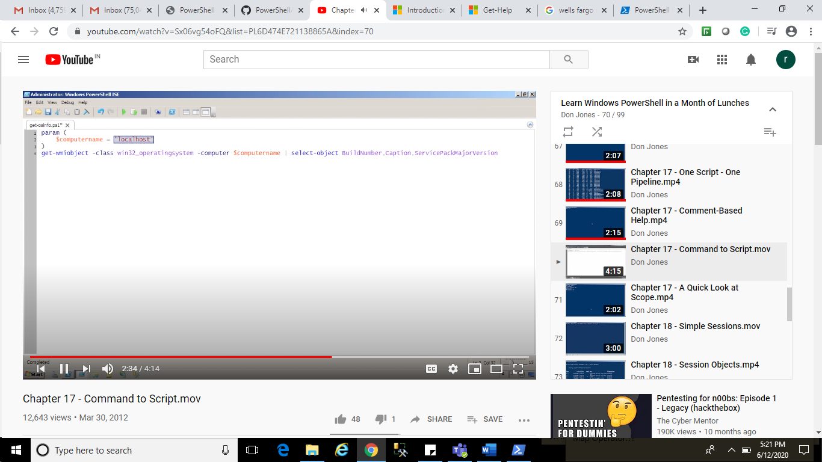

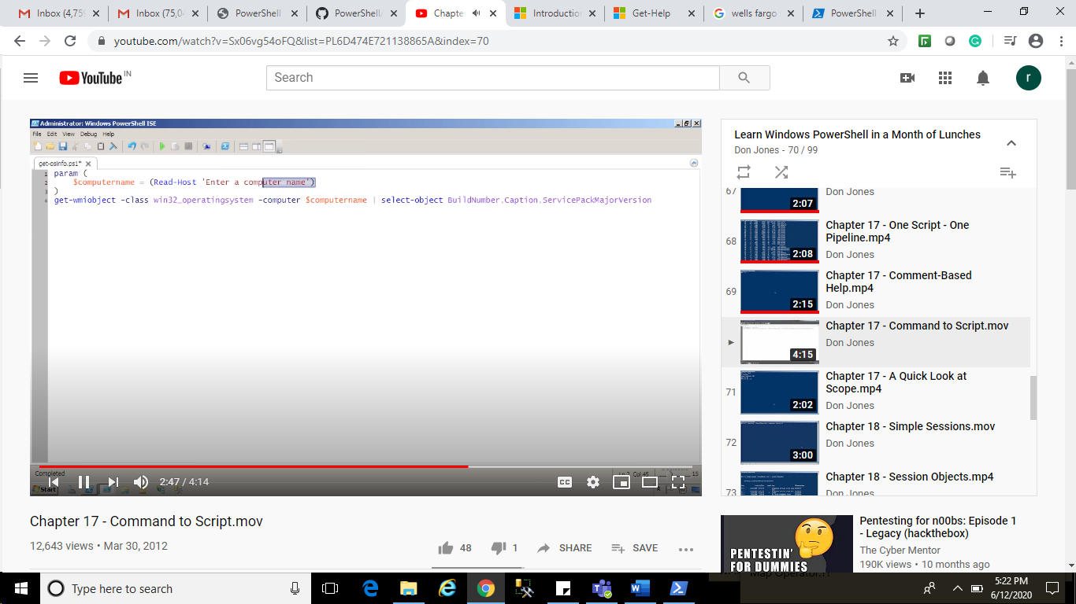

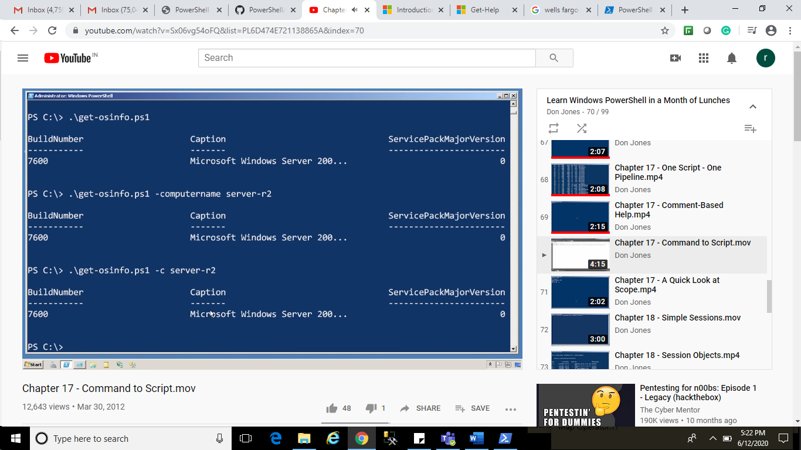

Session:

Help New-PSSession

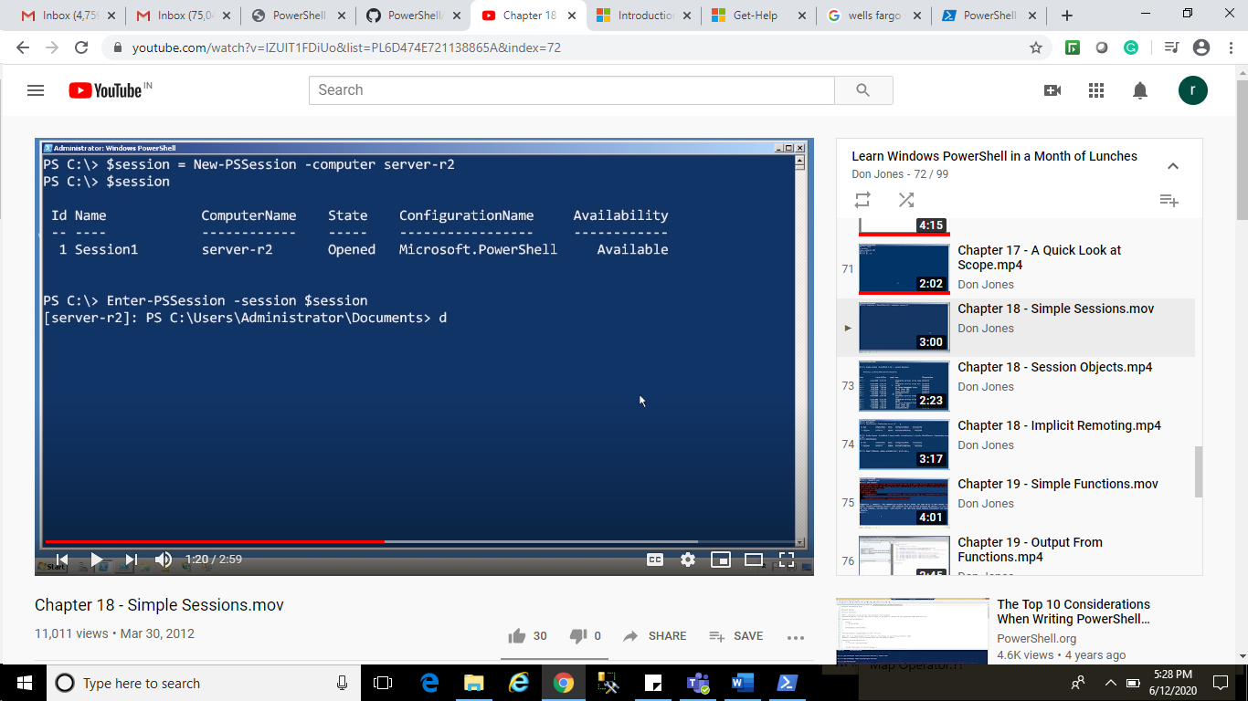

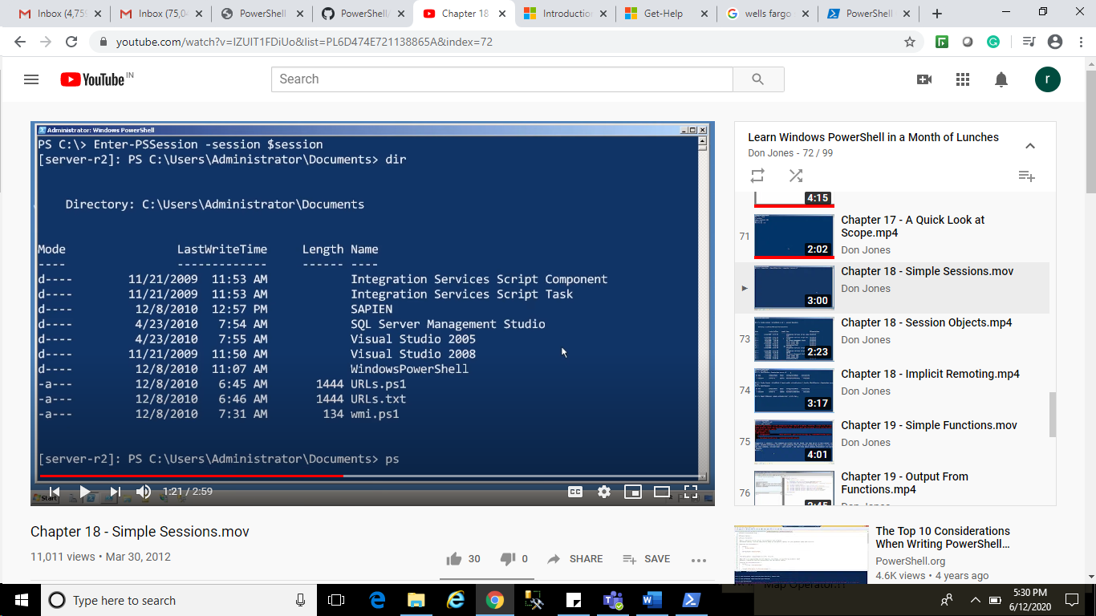

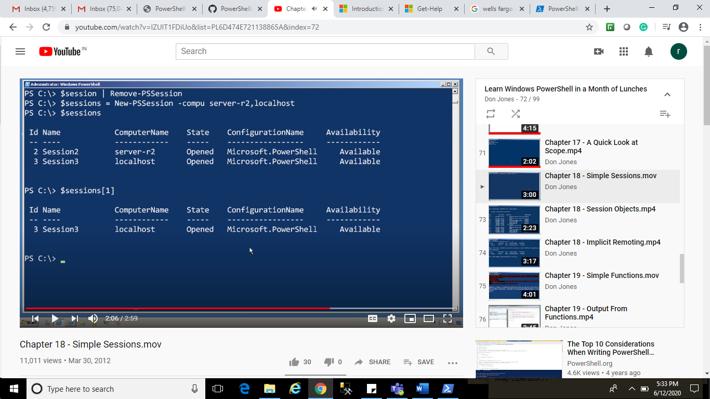

Exit-PSSession

$session | Remove-PSSession

Session-Object:

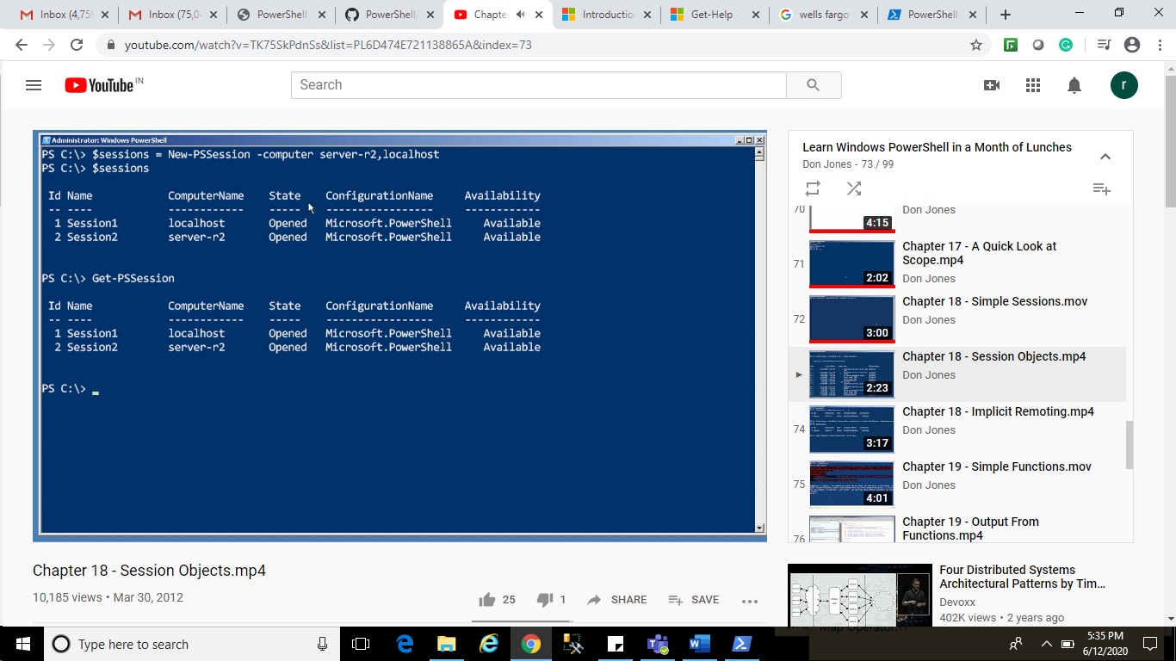

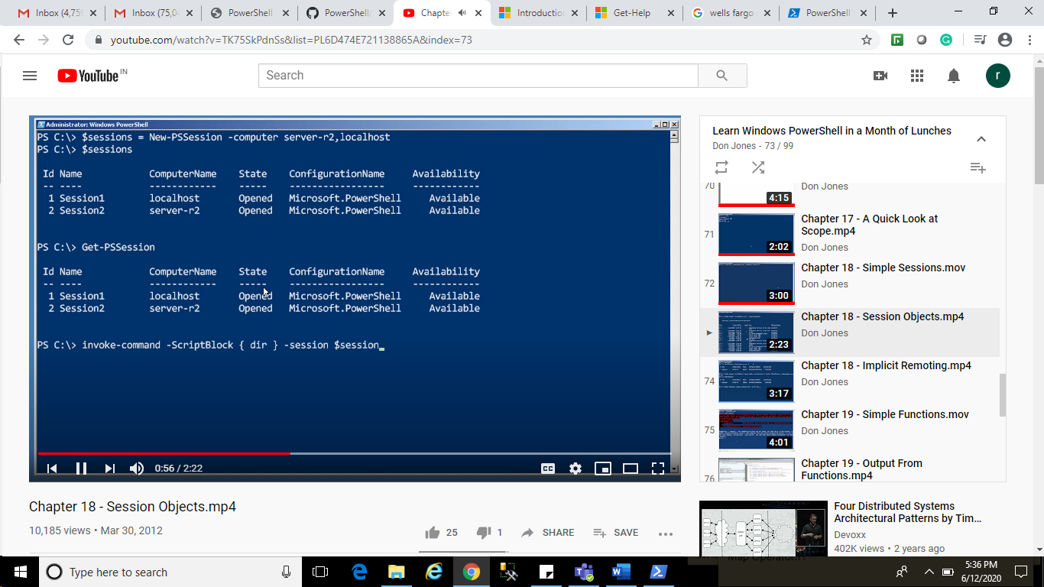

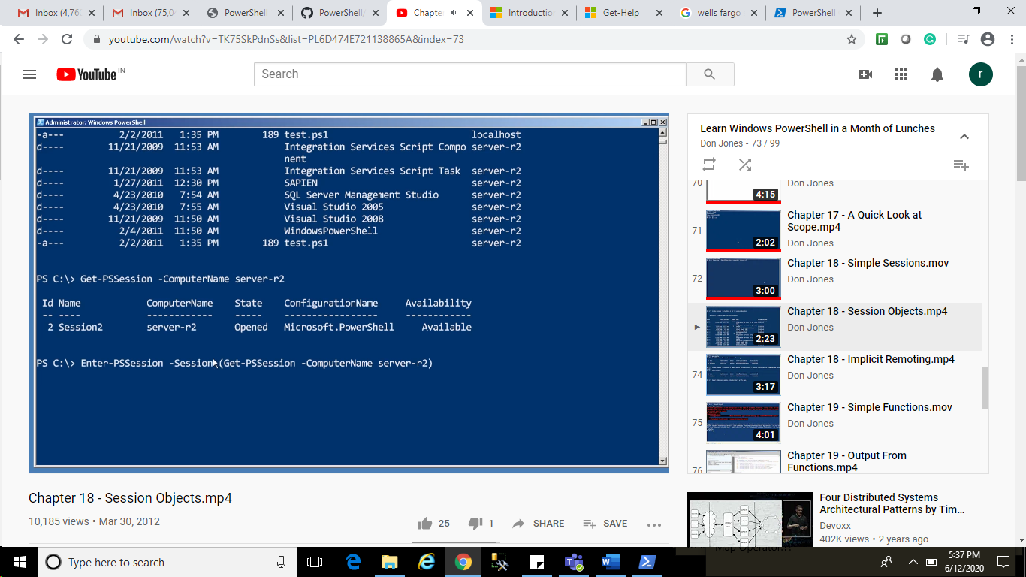

Implicit Remoting:

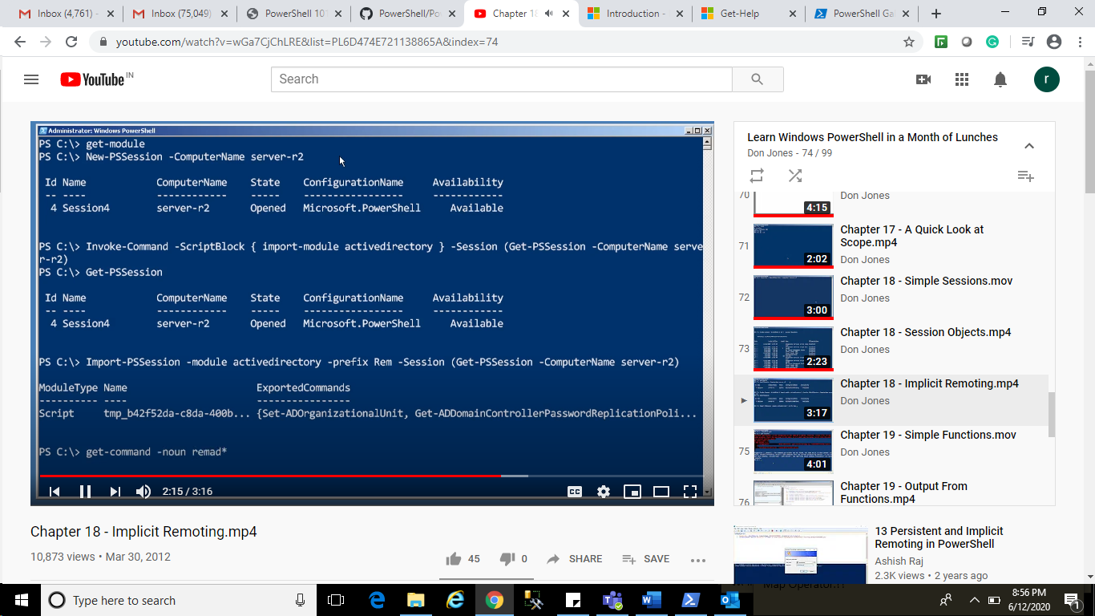

Help remaduser

Simple Function :

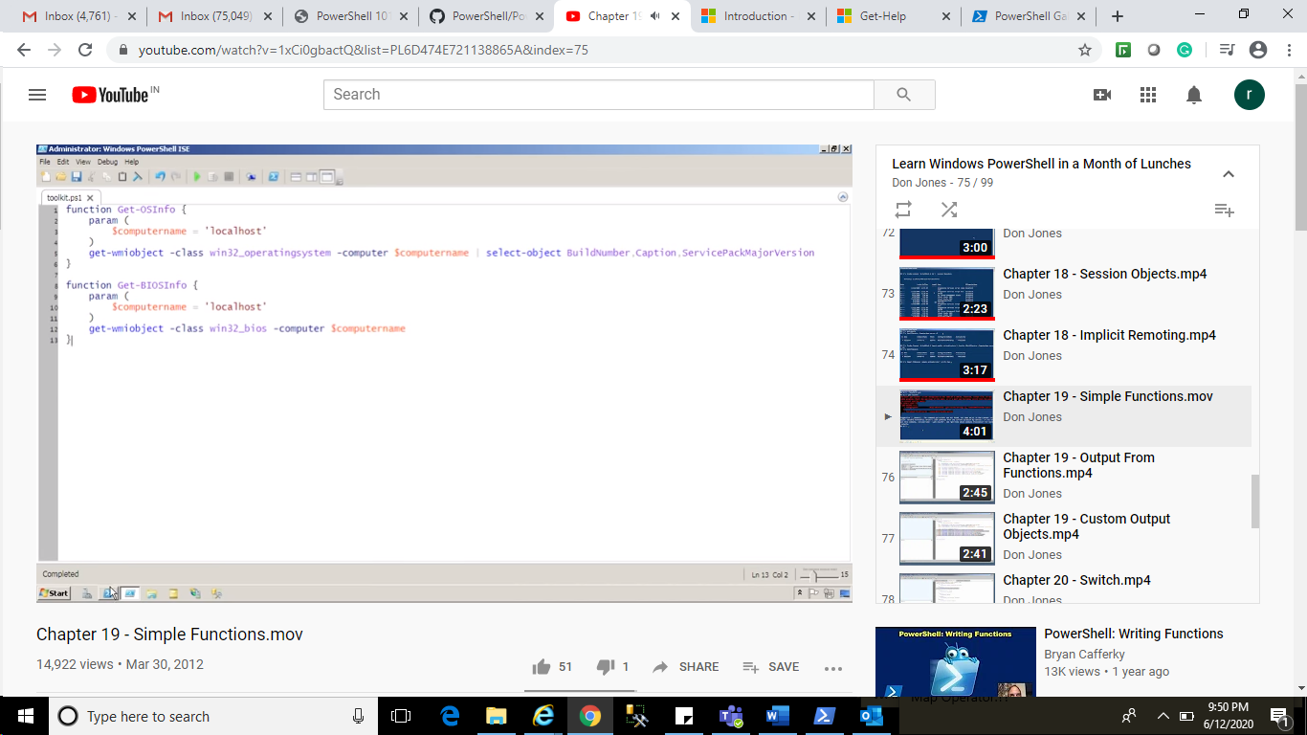

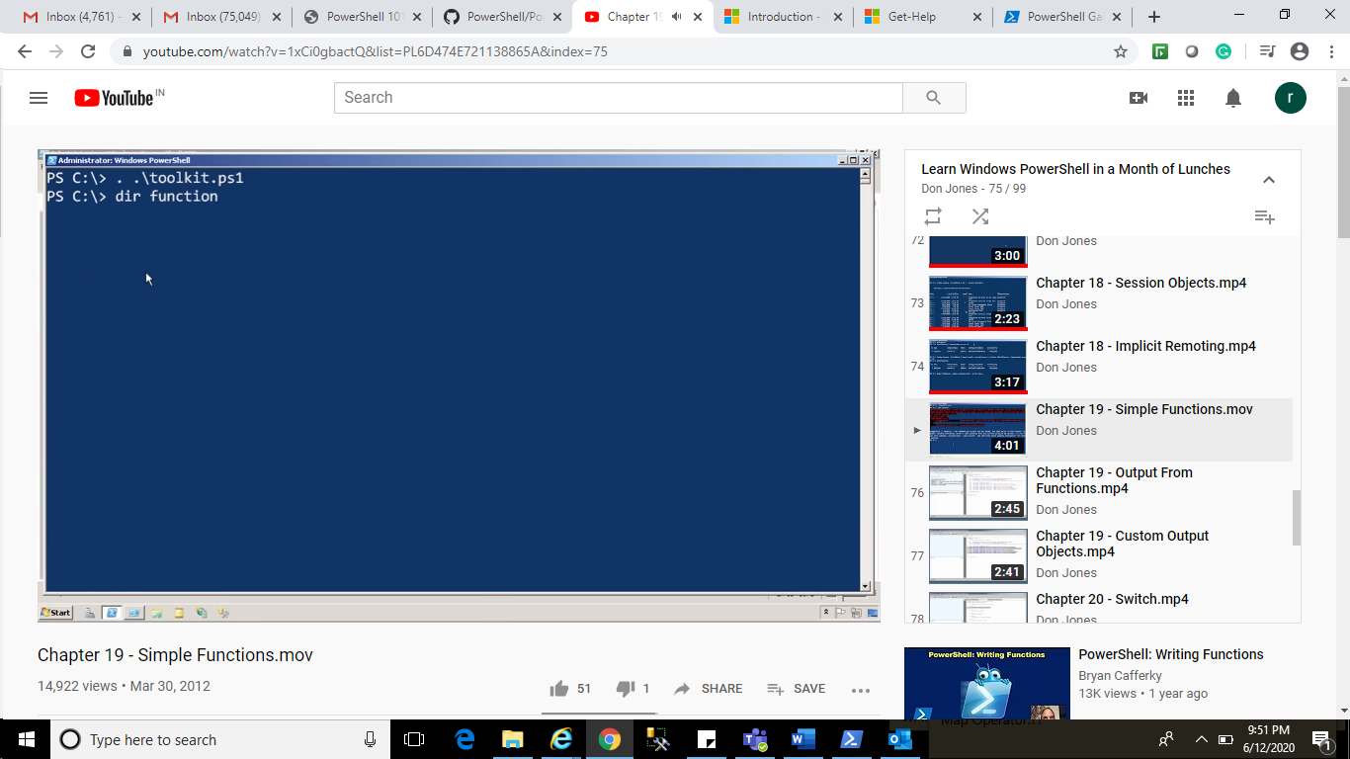

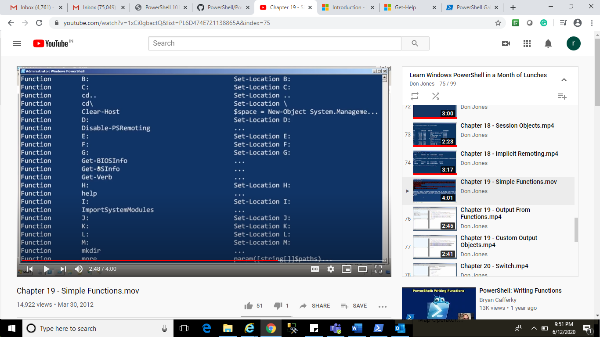

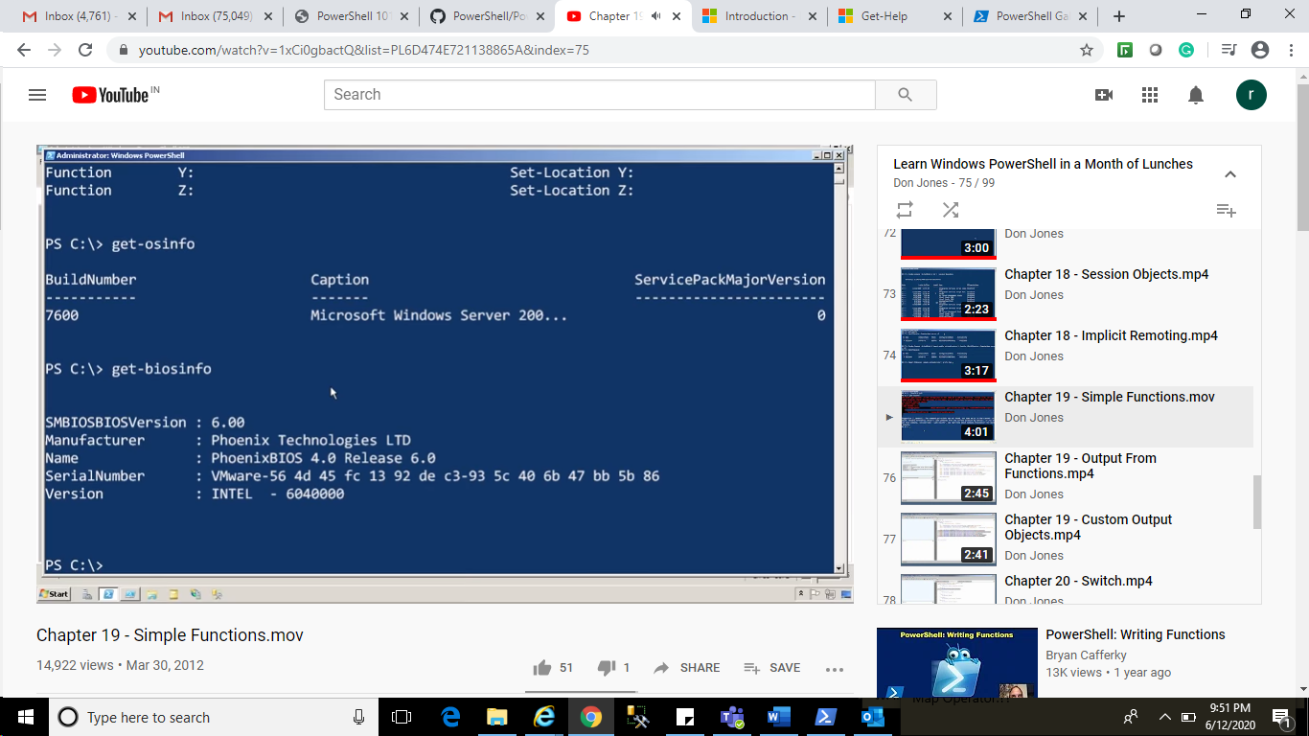

OutPut from Function:

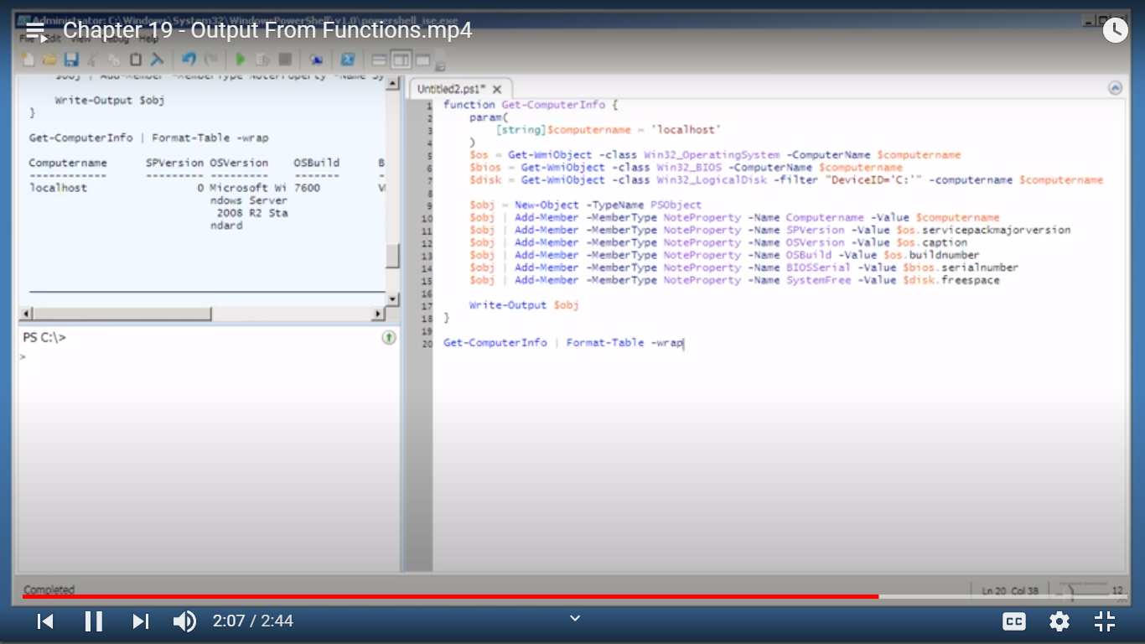

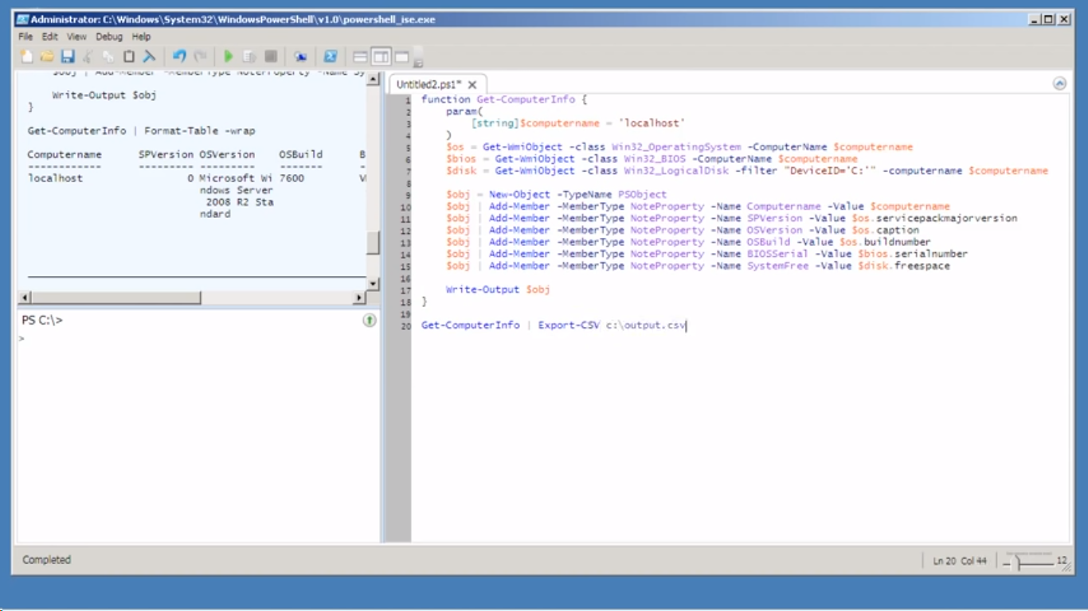

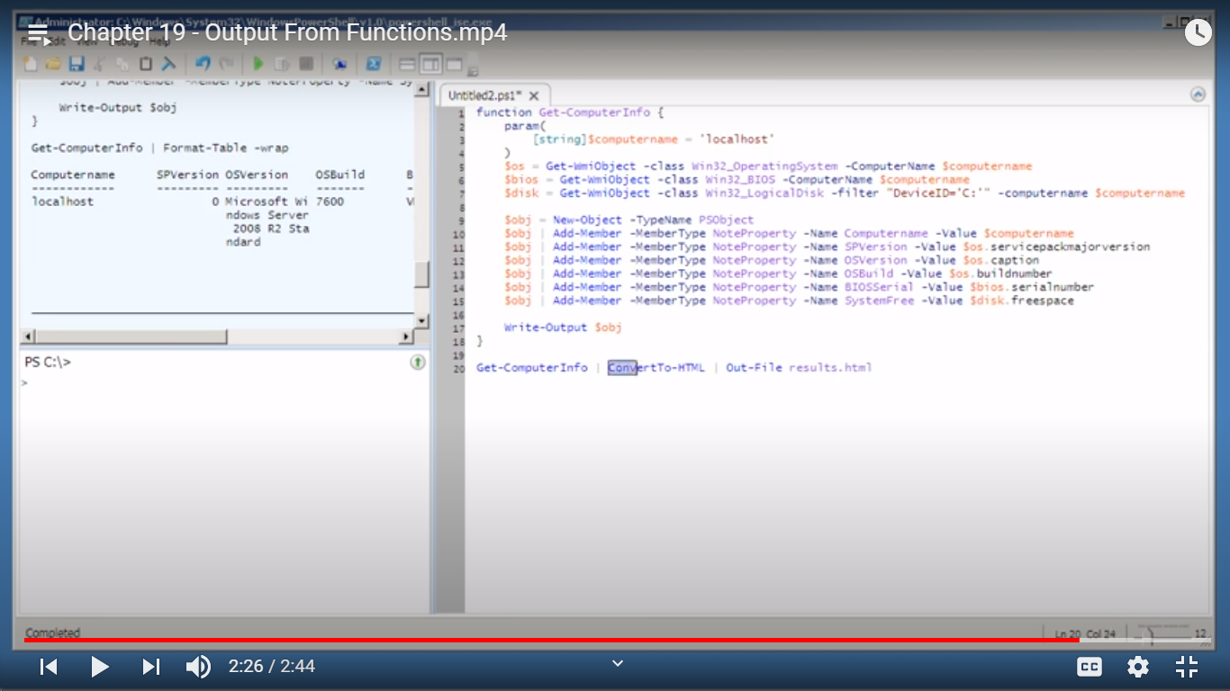

Custome Output Object:

Switch:

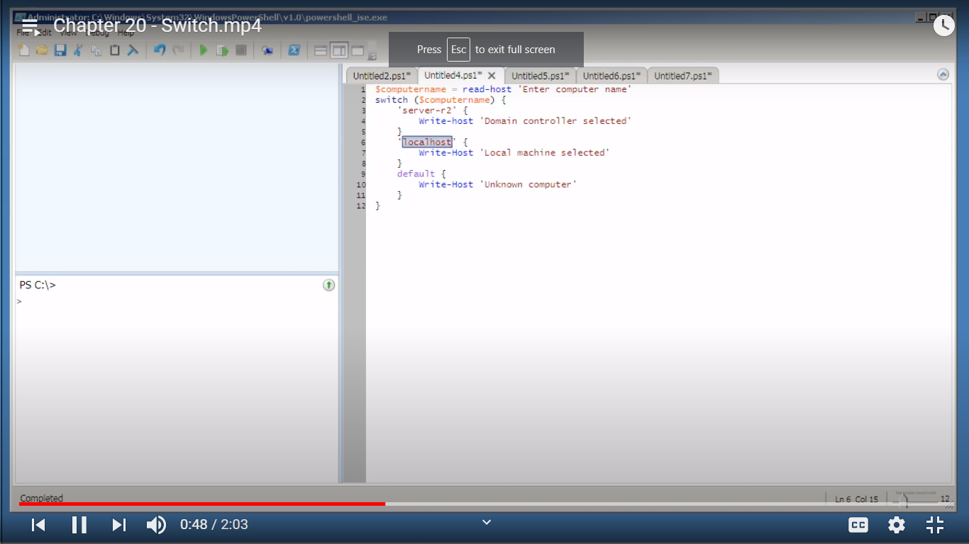

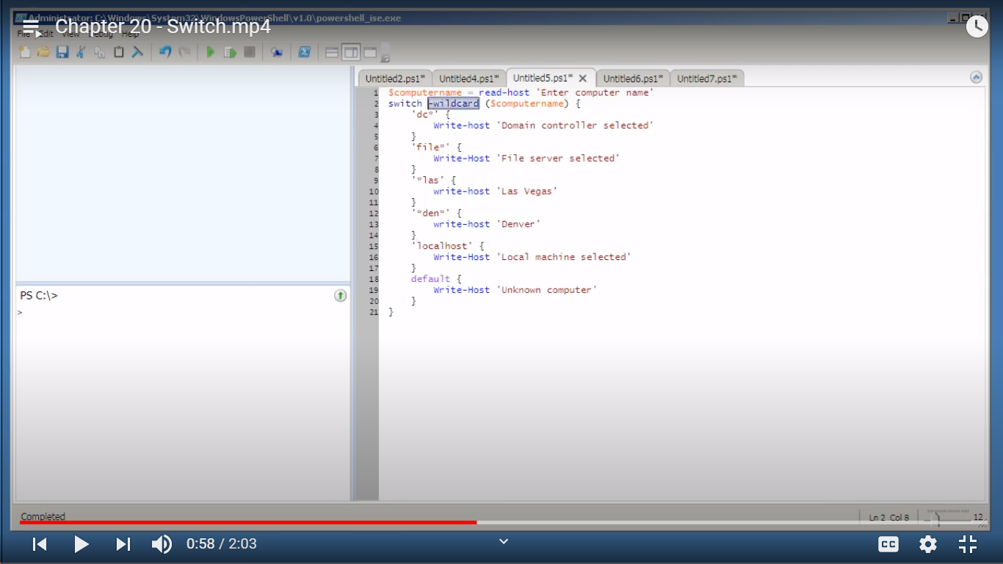

If Construct:

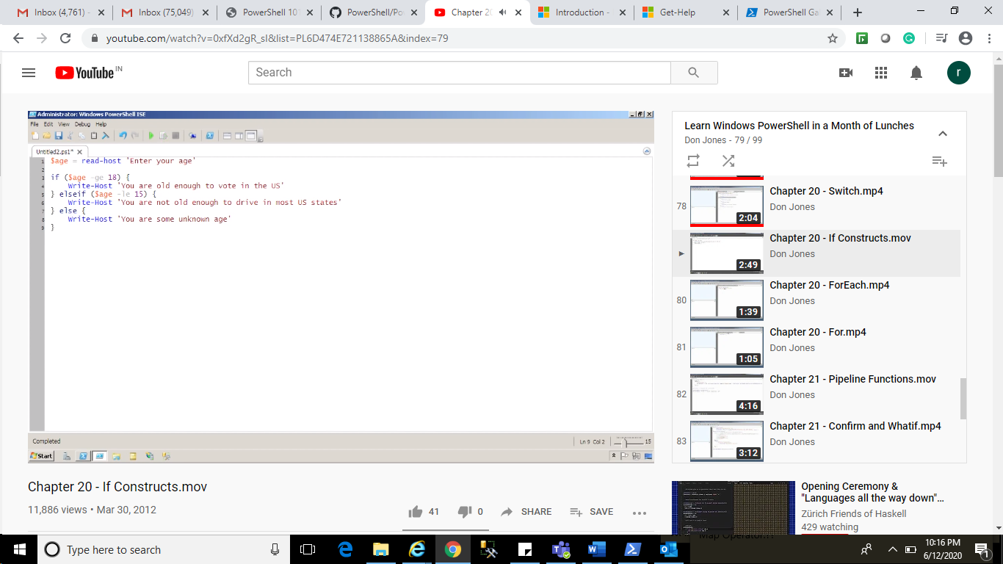

ForEach:

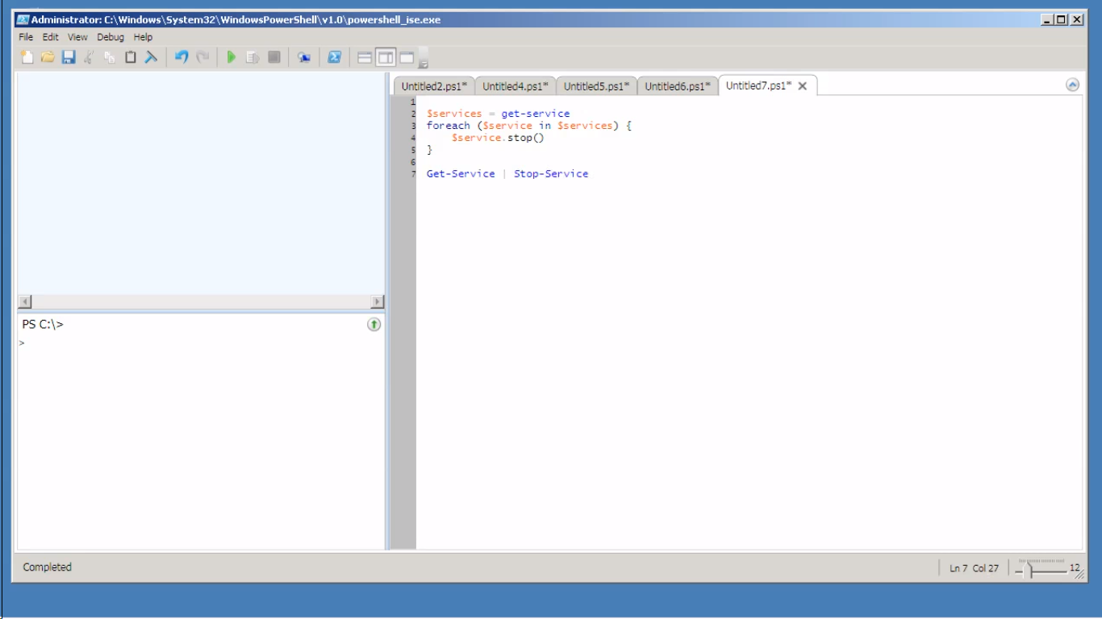

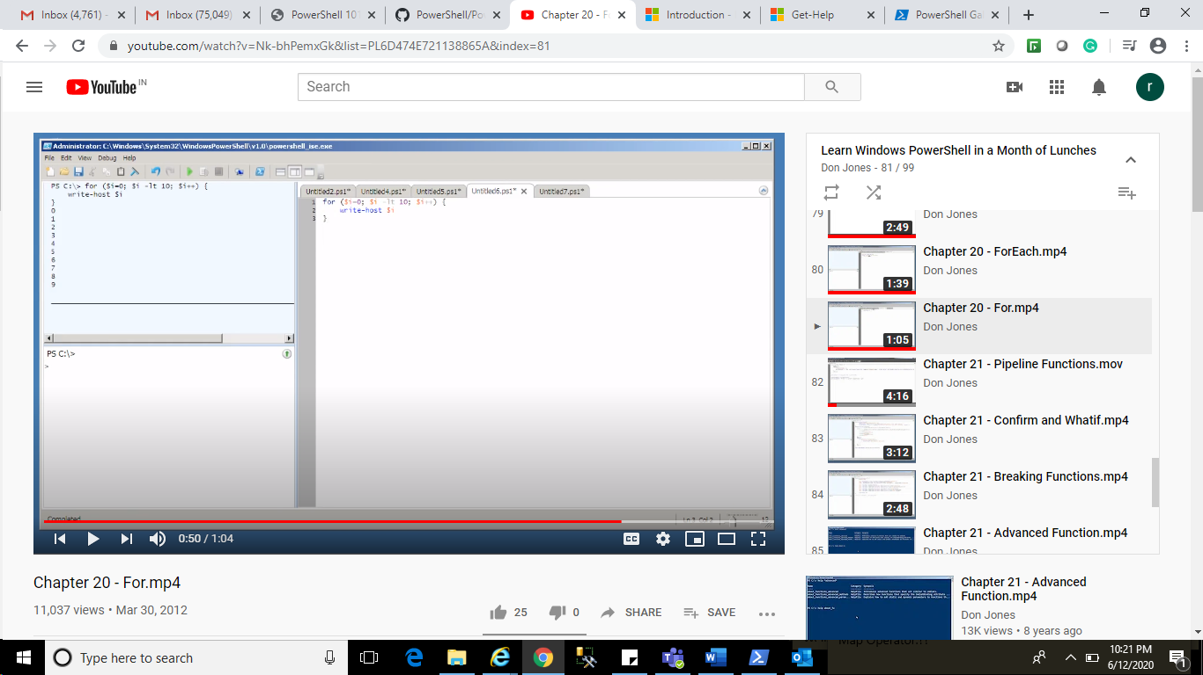

Pipeline Function:

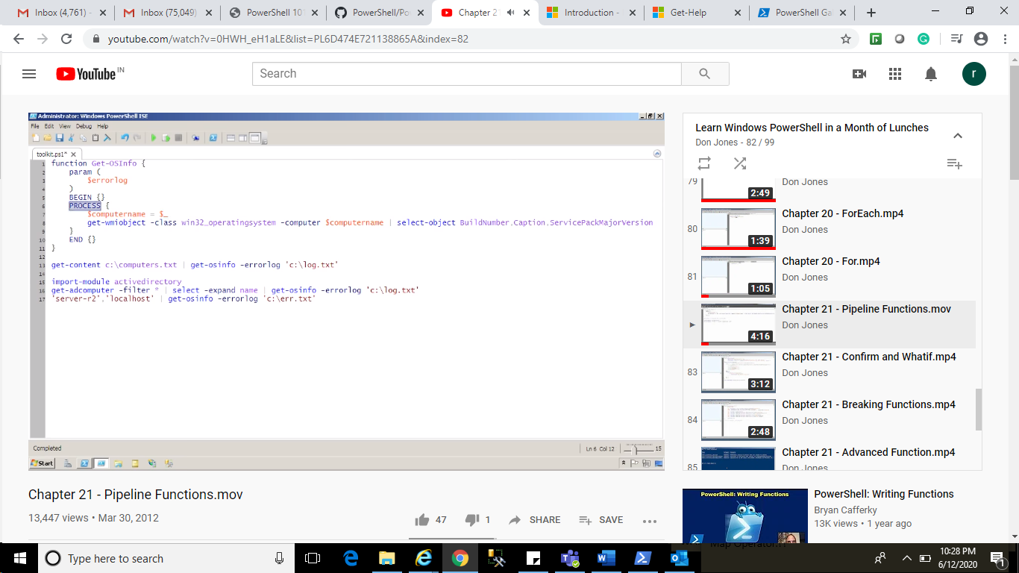

Confirm and What If:

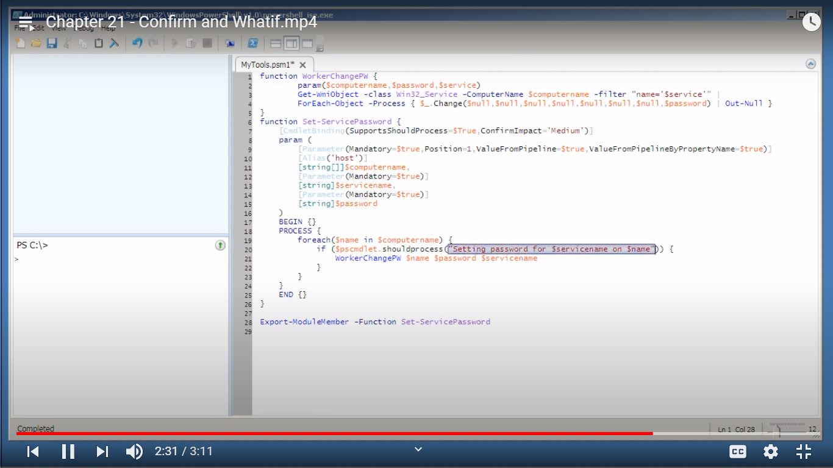

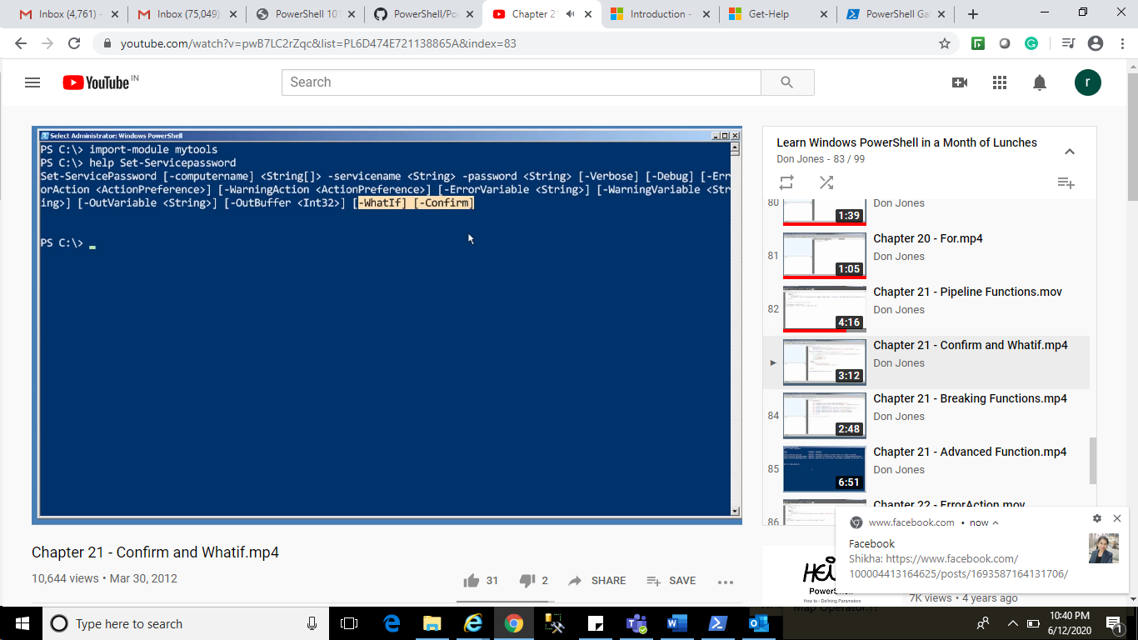

Breaking Function:

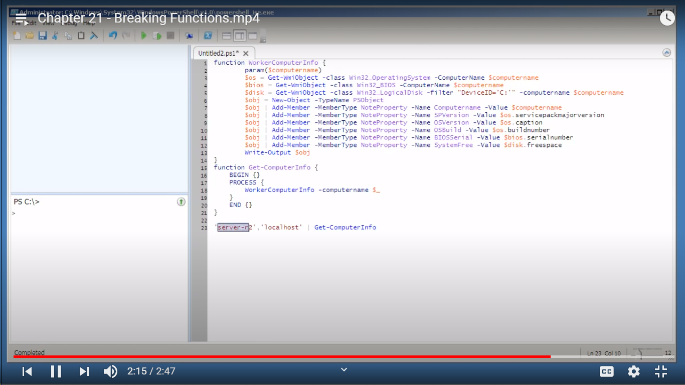

Advanced Function:

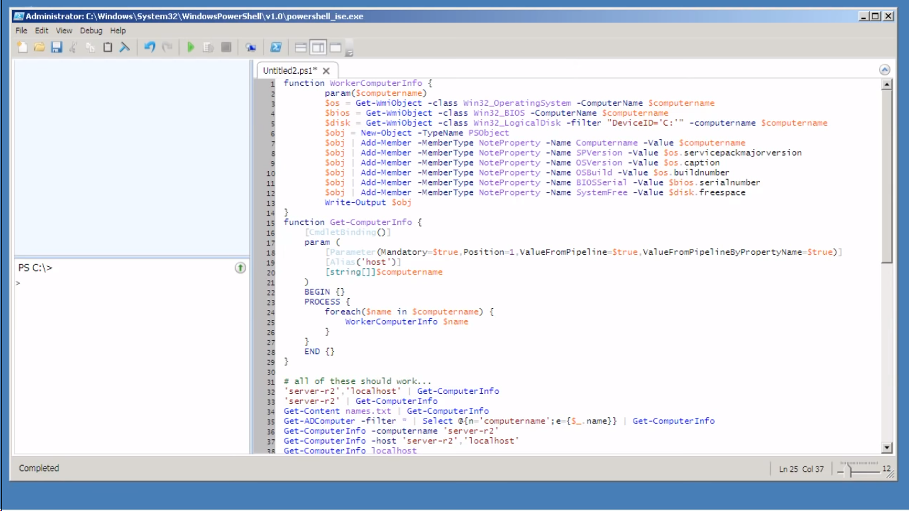

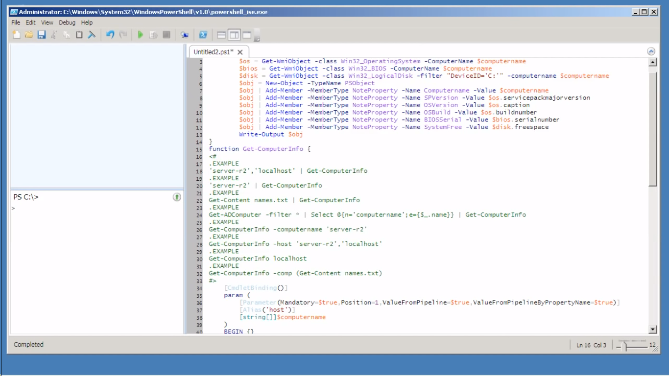

Error Action:

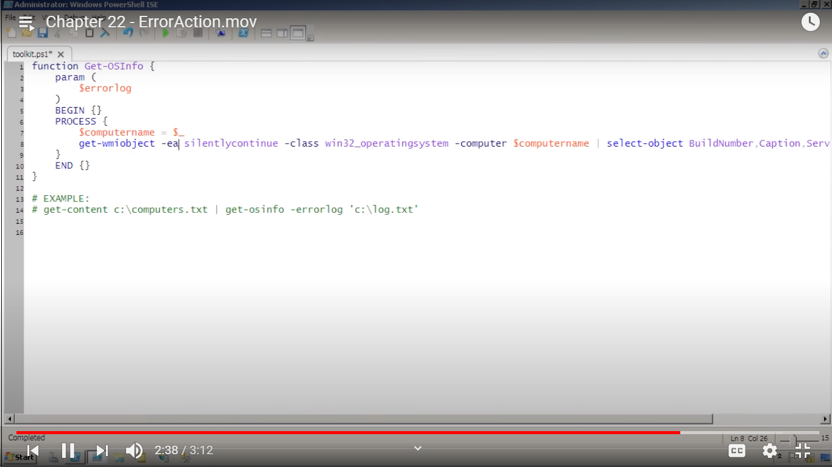

Trap:

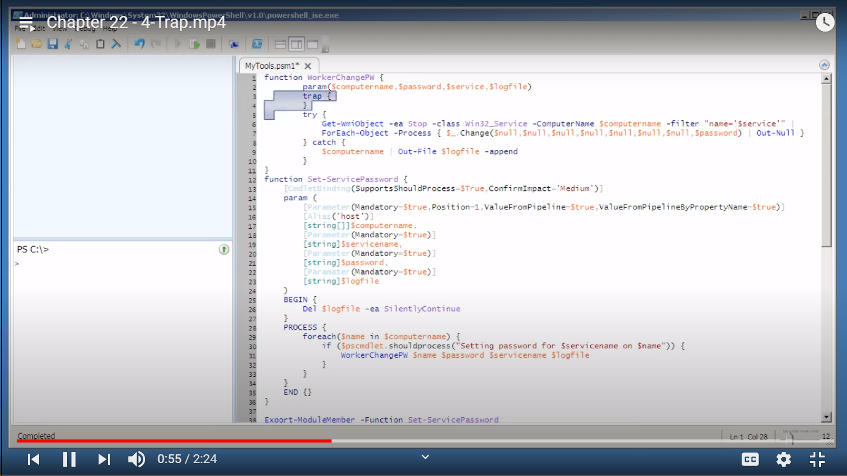

Logging Failed:

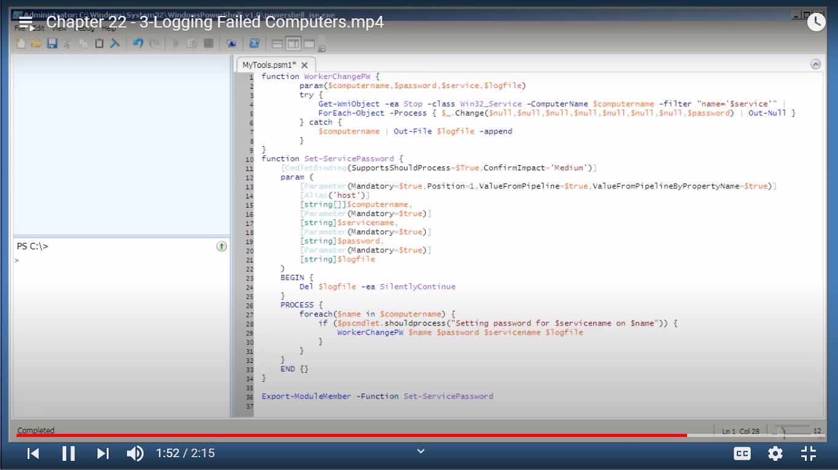

Error Variable:

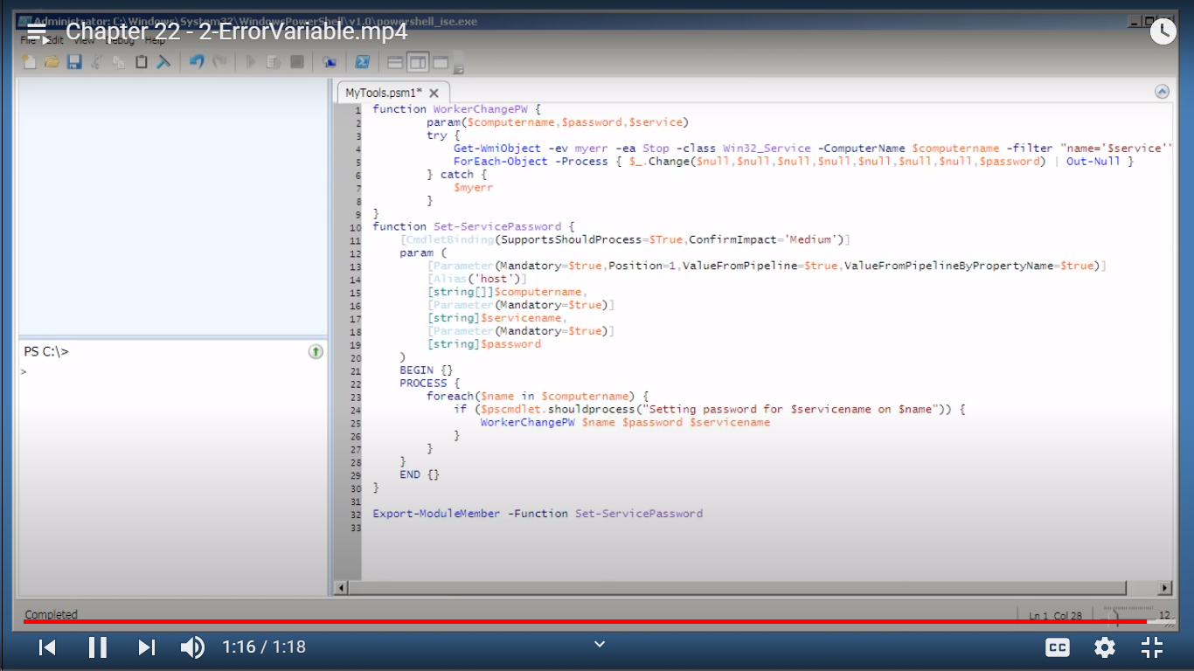

Using Write Debug:

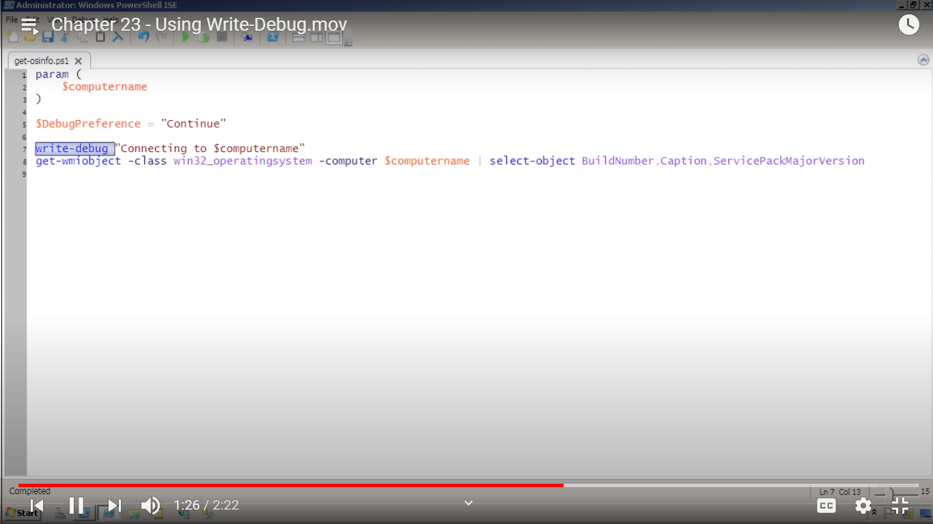

Manipulating String:

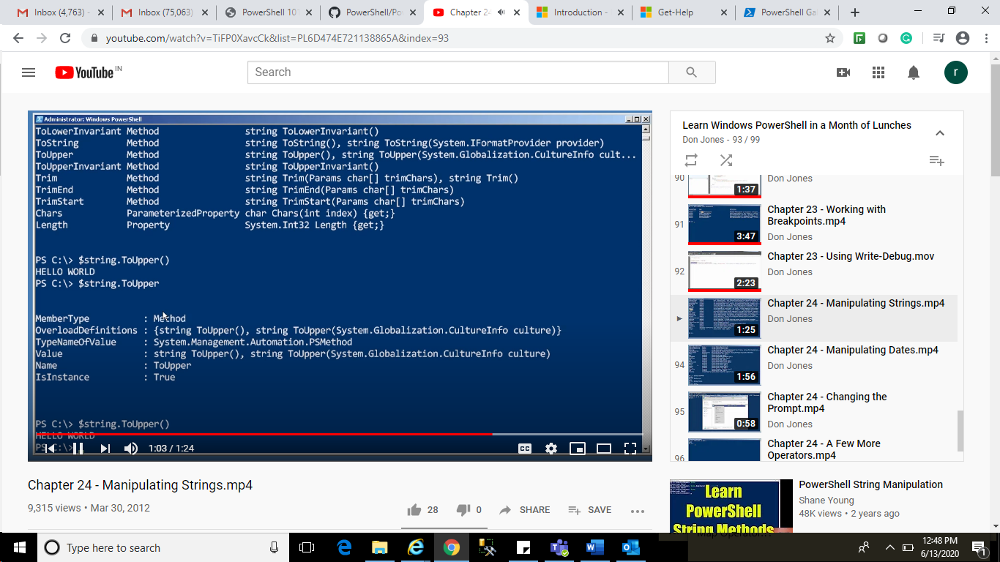

Manipulate Dates:

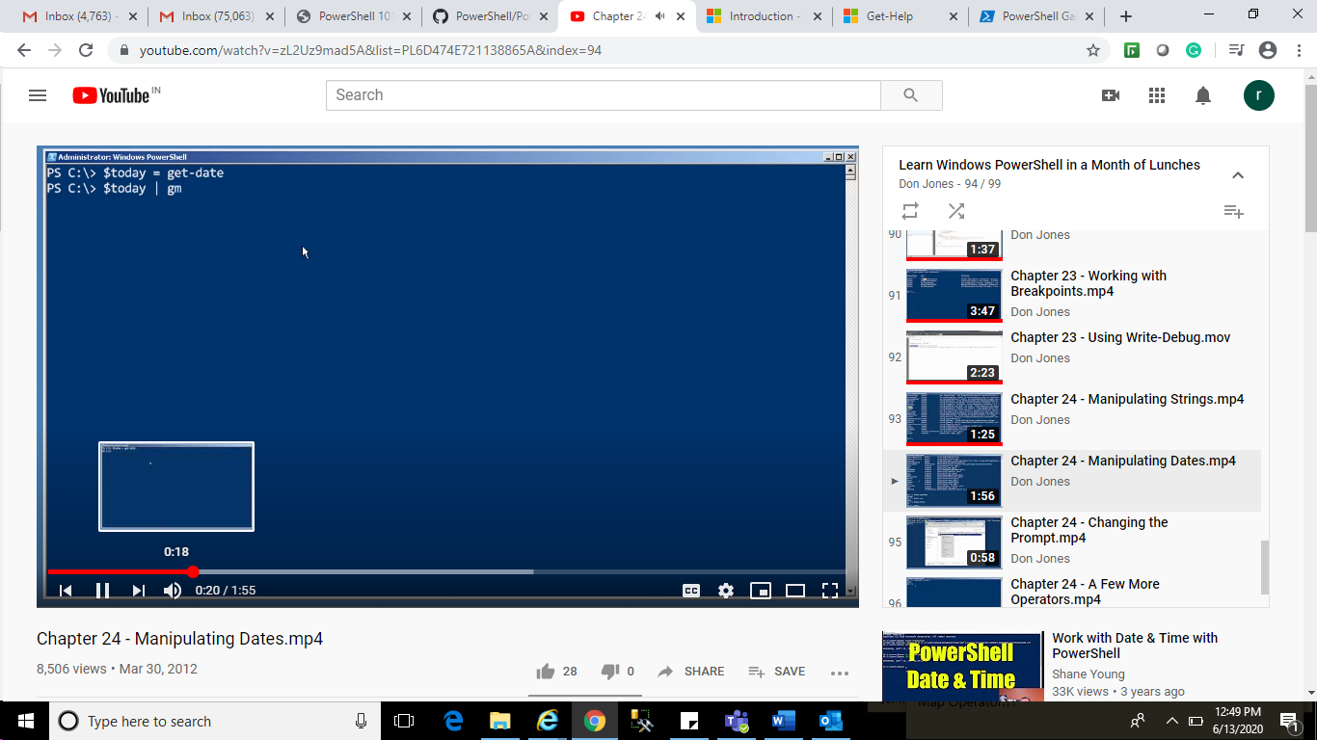

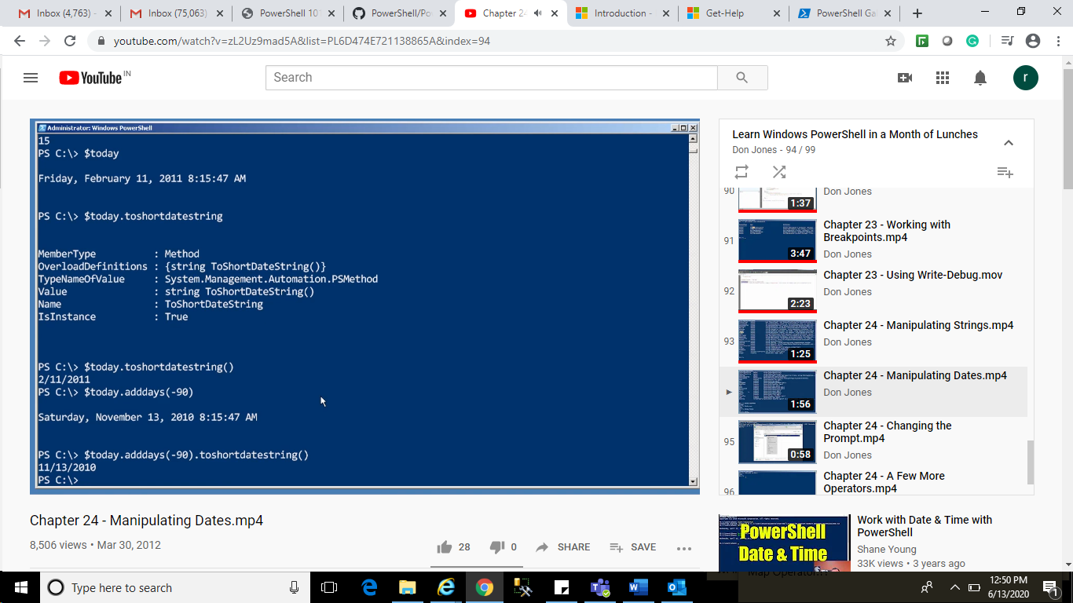

Changing Prompt:

Profile Script: